FINITE-WIDTH STRESS CONCENTRATIONS OF ISOTROPIC PLATES AND LAMINATED COMPOSITES

Fung-En Harn

8515 Park Lane # 1604, Dallas, TX 75231, USA

Abstract

The notched strength of the infinite-width or finite-width isotropic plate is a classical and an extensively studied topic in the literature. Both the analytical solutions and the experimental investigations are widely and successfully achieved. The fundamental study of infinite-width laminated composite with a hole has already completed. However, the exact analytical solution for the finite-width laminated composite is not available. Based on the solution of infinite-width isotropic plate containing a hole, finite-width isotropic stress concentration factor (SCF), and finite-width orthotropic SCF, the approximate solutions of axial stress distribution (stress concentrations) along the net cross section for finite-width isotropic plate and finite-width laminated composite, respectively, are obtained successfully. Results of the stress concentrations obtained from analytical approximation, finite element analysis, and experimental investigation are in good agreement for isotropic plate with various hole diameter-to-plate width (d/w) ratios and laminated composites with various d/w ratios, lay-ups, and material systems.

1. INTRODUCTION

The stress or strain concentration tangential to the hole edge has been investigated extensively for isotropic materials for a century. The equations of the state of stress have been developed for both infinite- and finite-width isotropic plates. The fundamental work in the hole problems for infinite-width isotropic plate was completed by Timoshenko and Goodier's [1]. The state of stress in the finite-width isotropic strip with a hole has been studied by Howland [2]. In his work, the influence from the short distance between the free straight edges and hole edge on the stresses around the hole edge, within the strip, and near the straight edges is quite distinct. When the hole size is larger in a fixed width of the strip, the axial stress increases more at the hole edge (larger stress concentration) but drops below the far field stress at the straight edges. Sternberg and Sadowsky [3] have developed an approximate three-dimensional solution for the stress distribution around a circular hole in an infinite-width isotropic plate of arbitrary thickness.
The analytical solutions to the stress or strain concentrations for infinite-width anisotropic plate have been well-established couples of decade ago. Lekhnitskii [4] and Savin [5] investigated a hole in an infinite-width anisotropic plate and developed analytical solutions by employing complex variable techniques. In the infinite-width orthotropic plate, an approximate solution of the in-plane stress concentration problems has been developed by Whitney and Konish [6], and Ko [7]. In the past twenty years or so, the solutions to the finite-width laminated composites with a hole have been obtained via boundary collocation method, and two- and three-dimensional finite element analyses. In a finite-width laminate, the Airy stress function in terms of full Laurent's series and Lekhnitskii' solutions in conjunction with the boundary collocation method are employed to solve the stress distributions within the notched laminates [8 to 10]. Several investigations [11 to 14] have used boundary layer theory, Lekhnitskii's or Savin's solutions to determine the interlaminar stresses near the curved and straight boundaries. Traditionally, the finite-width correction (FWC) factor for notched isotropic plate is applied to the infinite-width laminated composites to obtain the corresponding finite-width solutions. However, this approach only works well on quasi-isotropic laminates. Recently, the FWC factors for anisotropic plates have been formed by Tan [15]. It is a function of d/w and material properties. The axial stress distribution for a finite-width anisotropic plate containing a hole is obtained by directly multiplying the anisotropic FWC factor to the corresponding Lekhnitskii's equation.
When the laminae with different fiber orientations are stacked and cured, the interlaminar stresses can be induced near the boundaries due to the Poisson’s ratio mismatch, shear stress coupling or both between plies. Due to the stiffness discontinuity between plies in the laminated composite, the interlaminar stress concentrations near the hole and straight edges are the major concerns in the study of edge effect on the notched strength of composites. In the region adjacent to the laminate edges, the plane stress solutions may not be applicable. The stresses in the boundary layer exhibit in the asymptotic nature. The extensive study of the boundary layer theory and interlaminar stresses can be found in the literatures [16 to 25]. It is believed that the interlaminar stresses play important roles in the delamination at the ply interface. Chan and Ochoa [26] have developed a finite element scheme to study the delamination characteristics of laminates subjected to various loading conditions. They found that the interlaminar stresses can be significantly reduced by minimizing the Poisson’s ratio mismatch. Shah and Chan [27] applied Chan and Ochoa’s finite element scheme to investigate the interlaminar stress distribution around the hole of an infinite-width laminate.
It is well known that under plane stress assumption for infinite-width isotropic plate with a hole, the axial stress raises many times of the far field uniaxial stress at hole edge, and recovers to the far field uniaxial stress at the plate straight edges. In the study of edge effect on the unnotched laminated composites under uniaxial tensile load, the axial stress near the straight boundaries drops a little bit below the applied stress. Hence, for a laminate with fixed width and a larger hole (d/w ≥ 0.2, for general cases), the axial stress distribution is expected to be like but not like as shown in Fig.1. Curve is obtained directly by multiplying curve by a FWC factor. The areas under the curves and , respectively, must be identical due to the force balance with the same applied load. However, the areas under the curves and , respectively, may not be the same. In Fig.1, the infinite-width SCF, , the finite-width SCF, , and the respective axial stress distributions are dependent on the lay-up and material system.
Approximate solutions of axial stress distributions for finite-width isotropic plates and finite-width laminated composites, respectively, are developed in this paper without the involvement of interlaminar stresses at the boundaries. The analytical solutions are in prominent agreement with the finite element solutions and experimental results.

2. ANALYTICAL SOLUTION FOR INFINITE-WIDTH LAMINATED COMPOSITES

For an infinite-width laminated composite containing one central hole and subjected to uniform tensile load in the y-direction (see Fig.1), the axial stress distribution [4], which is parallel to the loading direction along the x-axis, can be expressed as
$\begin{aligned}σ_{y}^{∞}(α,0)={\bar{σ}}_{y}+{\bar{σ}}_{y}\text{Re}\left\{\frac{1}{μ_{1}−μ_{2}}[\frac{−μ_{2}(1−{iμ}_{1})}{(α+\sqrt{α^{2}−1−μ_{1^{2}}})\sqrt{α^{2}−1−μ_{1^{2}}}}\right.+ \\ \left.\frac{μ_{1}(1−{iμ}_{2})}{(α+\sqrt{α^{2}−1−μ_{2^{2}}})\sqrt{α^{2}−1−μ_{2^{2}}}}]\right\},\end{aligned}$ (1)
in which, , R is the hole radius, and is the uniform external tensile stress.
x
y
Laminate Free Straight Edge
Fig.1. One quarter of a laminated composite with different hole sizes subjected to uniform tensile load. represents the axial stress distribution, for the laminate with a very small hole radius , and represent the axial stress distribution, for the same laminate with a much larger hole radius , is the SCF for the laminate with a very small hole size, is the SCF for the same laminate with a much larger hole size, is the uniform axial tensile load, and  w is the laminate width.

and are the principal roots (roots with positive imaginary part) of
(2)
in which, with i, j=1,2, and 6 are the compliances of the laminate in the Cartesian coordinates. Subscripts 1 and 2 are parallel and transverse to the loading direction, respectively. For orthotropic materials, .

3. FINITE-WIDTH ISOTROPIC AND ORTHOTROPIC SCF’S

Theoretically, the finite-width SCF can be related to the infinite-width SCF through a FWC factor. The finite-width SCF for isotropic plate containing a circular cutout was found by Heywood [28]:
$K_{T}^{'}=K_{T}^{∞^{′}}\left[\frac{2+(1−dw)^{3}}{3(1−dw)}\right],$ (3)
in which is the infinite-width isotropic SCF, is the finite-width isotropic SCF, d is the hole diameter, and w is the plate width. The expression in the brackets is the FWC.
The concept and technique for deriving the finite-width SCF for laminated composites are presented as follows. Refer to Fig.1, the requirement of the force balance must be satisfied for the laminate with a very small or a very large hole size. That is, the total applied force per unit laminate thickness must equal to the force integration along the net cross section of the laminate.
$\int{σ_{y}^{C_{1}}(ξ_{1},0)\text{.}R_{1}{dξ}_{1}=\int{{\bar{σ}}_{y}\text{.}R_{1}{dξ}_{1}={\bar{σ}}_{y}\text{.}\frac{w}{2}=P}},$ (4)
$\int{σ_{y}^{C_{2}^{'}}(ξ_{2},0)\text{.}R_{2}{dξ}_{2}=\int{{\bar{σ}}_{y}\text{.}R_{2}{dξ}_{2}={\bar{σ}}_{y}\text{.}\frac{w}{2}=P}},$ (5)
in which, , , and P is the total applied uniform force per unit laminate thickness on one quarter of the laminate.
From Eqs.(4) and (5), it must be true that
$\int{σ_{y}^{C_{1}}(ξ_{1},0)\text{.}R_{1}{dξ}_{1}=\int{σ_{y}^{C_{2}^{'}}(ξ_{2},0)\text{.}R_{2}{dξ}_{2}}}\text{.}$ (6)
If , then the laminate with a very small hole radius can be considered as an infinite-width laminate; on the other hand, the laminate with a very large hole radius is the finite-width laminate.
Consider the partial area (force) integration under curve (the infinite-width laminate) in Fig.1. The integration starts from an arbitrary point on the x-axis, and ends to the laminate half width. The following relation can be established with Eq.(6),
$\int{σ_{y}^{C_{1}}(ξ^{'},0)\text{.}R^{'}dξ^{'}=m\text{.}\int{σ_{y}^{C_{1}}(ξ_{1},0)\text{.}R_{1}{dξ}_{1}}}=m\text{.}\int{{σ_{y}^{C_{2}^{'}}(ξ_{2},0)\text{.}R_{2}dξ}_{2}},$ (7)
in which, , and m is a constant within .
Let , and Eq.(7) can be rewritten as
$\int{σ_{y}^{C_{1}}(ξ_{2},0)\text{.}R_{2}{dξ}_{2}=}m\text{.}\int{σ_{y}^{C_{2}^{'}}(ξ_{2},0)\text{.}R_{2}{dξ}_{2}}=m\text{.}{\bar{σ}}_{y}\text{.}\frac{w}{2},$ (8)
or $\int{σ_{y}^{C_{1}}(ξ_{2},0){dξ}_{2}=}m\text{.}{\bar{σ}}_{y}\text{.}\frac{w2}{R_{2}}\text{.}$ (9)
In Eq.(9), replacing by , for the consideration of an infinite-width laminate, letting , R is the general hole radius, and then Eq.(9) becomes
$\int{σ_{y}^{∞}(ξ,0)dξ=}m\text{.}{\bar{σ}}_{y}\text{.}\frac{w2}{R}\text{.}$ (10)
in which, .
Since has already been found in Eq.(1), then the constant m in Eq.(10) is calculated as
$\begin{aligned}m=1−βM+\text{Re}\left\{\frac{1}{μ_{1}−μ_{2}}[\frac{μ_{2}}{1+{iμ}_{1}}(1−βM−{iμ}_{1}βM−\sqrt{1−(1+μ_{1}^{2})(βM)^{2}}\right.) \\ \left.−\frac{μ_{1}}{1+{iμ}_{2}}(1−βM−{iμ}_{2}βM−\sqrt{1−(1+μ_{2}^{2})(βM)^{2}})]\right\},\end{aligned}$ (11)
in which, , d is the general hole diameter, and w is the laminate width. Note that .
In Eq.(11), m is called the FWC factor for the finite-width laminated composites containing a hole. A magnification factor M is introduced in Eq.(11) for a better approximation of the finite-width SCF. The magnification factor is defined by Tan [15] as
$M^{2}=\frac{\sqrt{1−8\left[\frac{3(1−β)}{2+(1−β)^{3}}−1\right]}−1}{2β^{2}}\text{.}$ (12)
The finite-width SCF is defined as
(13)
and the infinite-width SCF is defined as
(14)
Replacing with , and being removed, Eq.(8) can be rewritten as
(15)
Combining Eqs.(13), (14), and (15), at , the finite-width SCF is obtained explicitly:
(16)
For symmetrically laminated composites, the finite-width SCF is defined as
$K_{T}=\frac{1}{m}\text{.}\left[1+\sqrt{2\left(\sqrt{\frac{E_{y}}{E_{x}}}−ν_{\text{yx}}\right)+\frac{E_{y}}{G_{\text{yx}}}}\right],$ (17)
in which, , , , and are defined by Chan and Chou [29]. They are the effective constants or the smear properties of the laminated composite with y and x parallel and transverse to the loading direction, respectively.

4. APPROXIMATE FINITE-WIDTH ISOTROPIC SOLUTION

Consider an isotropic plate containing a very small central hole with radius subjected to a uniform tension load in the y-direction as shown in Fig.1. The boundary conditions at the hole edge with (imaginary) and in the polar coordinates are
(18)
The above boundary conditions are consisted of three parts [1]. The first part is the uniform external stress , which produces stresses at the imaginary hole edge:
$\begin{aligned}{\tilde{σ}}_{r}=\frac{{\bar{σ}}_{y}2}{1−(2R_{1}w)^{2}}\left[1−{\left(\frac{R_{1}}{r}\right)}^{2}\right], \\ {\tilde{σ}}_{θ}=\frac{{\bar{σ}}_{y}2}{1−(2R_{1}w)^{2}}\left[1+{\left(\frac{R_{1}}{r}\right)}^{2}\right], \\ {\tilde{τ}}_{rθ}=0\text{.}\end{aligned}$ (19)
The second part is the radial stress , and the third part is the shear stress . The second and third parts may be derived from a stress function,
$φ=\left(C_{0}+C_{−2}r^{−2}+C_{2}r^{2}+C_{4}r^{4}\right)\text{cos}2θ\text{.}$ (20)
The corresponding stress components are determined as
$\begin{aligned}{\hat{σ}}_{r}=\frac{1}{r}\frac{∂φ}{∂r}+\frac{1}{r^{2}}\frac{∂^{2}φ}{∂θ^{2}}=−\left(2C_{2}+\frac{4C_{0}}{r^{2}}+\frac{6C_{−2}}{r^{4}}\right)\text{cos}2θ, \\ {\hat{σ}}_{θ}=\frac{∂^{2}φ}{∂r^{2}}=\left(2C_{2}+\text{12}C_{4}r^{2}+\frac{6C_{−2}}{r^{4}}\right)\text{cos}2θ, \\ {\hat{τ}}_{rθ}=\frac{∂}{∂r}\left(\frac{1}{r}\frac{∂φ}{∂θ}\right)=\left(2C_{2}+6C_{4}r^{2}+\frac{2C_{0}}{r^{2}}−\frac{6C_{−2}}{r^{4}}\right)\text{sin}2θ\text{.}\end{aligned}$ (21)
The constants in Eq.(20) are obtained by substituting the boundary conditions of Eq.(18) into Eq.(21):
${\begin{aligned}C_{0}=\frac{{\bar{σ}}_{y}}{Δ}R_{1}^{2}\left(β^{}−β^{}\right), \\ C_{−2}=\frac{{\bar{σ}}_{y}2}{Δ}R_{1}^{4}\left(−β^{}+β^{}\right), \\ C_{2}=\frac{{\bar{σ}}_{y}2}{Δ}\left(−4β^{}+3β^{}+β^{}\right), \\ C_{4}=\frac{{\bar{σ}}_{y}}{Δ}R_{1}^{−2}\left(β^{}−β^{}\right), \\ Δ=−8+2β^{}+\text{12 \{}β\end{aligned}}^{}−8β^{}+2β^{},$ (22)
in which, . In the following calculations, will be replaced by for the consideration of general hole sizes.
From the experimental observations of an isotropic plate containing a hole under uniform tensile load, the failure always occurs within the plate net cross section areas; the cracks may initiate at the points where the highest stress gradients exit. Based on that, only the stress distribution in the y-direction along the x-axis is interested. In the finite-width cases, the boundary conditions at the hole edge, (R is the general hole radius) are satisfied automatically as the third equation in Eq.(18). The boundary conditions at the finite-width plate straight edges in the Cartesian coordinates are
(23)
In the literatures, the d/w ratio is usually considered to be zero for the infinite-width plate, hence the constants in Eq.(22) are simplified. When d/w ratio becomes much larger (, for example), those constants are assumed to be related to the corresponding constants in the stress solutions of the finite-width plate.
Two finite-width coefficients for isotropic materials, and are introduced to approximate the stress in finite-width isotropic plate:
$\begin{aligned}σ_{θ}=κ^{'}{\tilde{σ}}_{θ}+κ^{''}{\hat{σ}}_{θ} \\ κ^{'}\frac{{\bar{σ}}_{y}2}{1−β^{2}}\left[1+{\left(\frac{R}{r}\right)}^{2}\right]+κ^{''}\left(2C_{2}+\text{12}C_{4}r^{2}+\frac{6C_{−2}}{r^{4}}\right)\text{cos}2θ,\end{aligned}$ (24)
in which the first finite-width coefficient for isotropic material, is defined as $\left(1+β\right)$; the second finite-width coefficient for isotropic material, is determined by applying the finite-width SCF, in Eq.(3).
Consider , and then becomes the axial stress distribution in the finite-width isotropic plate, . Eq.(24) can now be rewritten as
$\frac{σ_{y}^{'}(η,0)}{{\bar{σ}}_{y}}=\frac{1}{2}\left\{\frac{1+β^{2}η^{−2}}{1−β}\right.+\frac{2κ^{''}}{Δ}[\left(−4β^{4}+3β^{2}+β^{−2}\right)+\text{12}\left(β^{2}−1\right)η^{2}+\left.3\frac{\left(β^{2}−β^{6}\right)}{η^{4}}]\right\},$ (25)
in which, , and it is defined within .
The l.h.s. of Eq.(25) at is nothing but the finite-width SCF. The second finite-width coefficient is then found by substituting Eq.(3) into the l.h.s. of Eq.(25):
$κ^{''}=\left\{\frac{K_{T}^{∞^{′}}\left[2+{\left(1−β\right)}^{3}\right]−3}{3\left(1−β\right)}\right\}\frac{\left(−4+β^{−2}+6β^{2}−4β^{4}+β^{6}\right)}{2\left(β^{−2}−3β^{2}+2β^{4}\right)}\text{.}$ (26)
The good agreement between Eq.(25) and Howland's isotropic finite-width solutions is found in Fig.2(a) for various d/w () ratios. The comparisons of Eq.(25) and finite element analysis (FEA) solutions conducted by Harn [30] for different d/w ratios are shown in Fig.2(b). From the observations in Fig.2, the point at which the axial stress recovers to the uniform tensile load shifts toward the plate straight edge when the d/w ratio becomes greater. The axial stress at the straight edge drops further from the uniform tensile load when the distance reduces between the hole edge and the straight edge. When the d/w ratio becomes much larger, d/w=0.85, for example, the axial stress distribution tends to be linear. It is reasonable to conclude that the failure of an isotropic plate containing a central hole initiates at the hole edge where the highest stress concentration achieves. It is also valid to determine that higher the d/w ratio, greater the stress concentration, and lower the notched strength of the plate is.

5. APPROXIMATE FINITE-WIDTH SOLUTION FOR LAMINATED COMPOSITES

The solution for finite-width laminated composite is approximated by adding a function [6] to the finite-width solution for isotropic plate, Eq.(25):
(27)
in which,
$f=b_{1}β^{q}η^{−q}+b_{2}β^{\left(q+2\right)}η^{−\left(q+2\right)}\text{.}$ (28)
In Eq.(28), q is an even integer for symmetric stress distribution with respect to the
y-axis.
Two equations are needed to solve the coefficients, and in Eq.(28). One equation is obtained by assuming the following relation also existed,
$\frac{σ_{y}(η,0)}{{\bar{σ}}_{y}}=\left(\frac{K_{T}}{K_{T}^{'}}\right)\frac{σ_{y}^{'}(η,0)}{{\bar{σ}}_{y}},$ (29)
Apply Eqs.(27) and (28) at (R is the general hole radius):
$b_{1}+b_{2}=\left(\frac{K_{T}}{K_{T}^{'}}−1\right)\frac{σ_{y}^{'}(β,0)}{{\bar{σ}}_{y}}=Y\text{.}$ (30)

a)
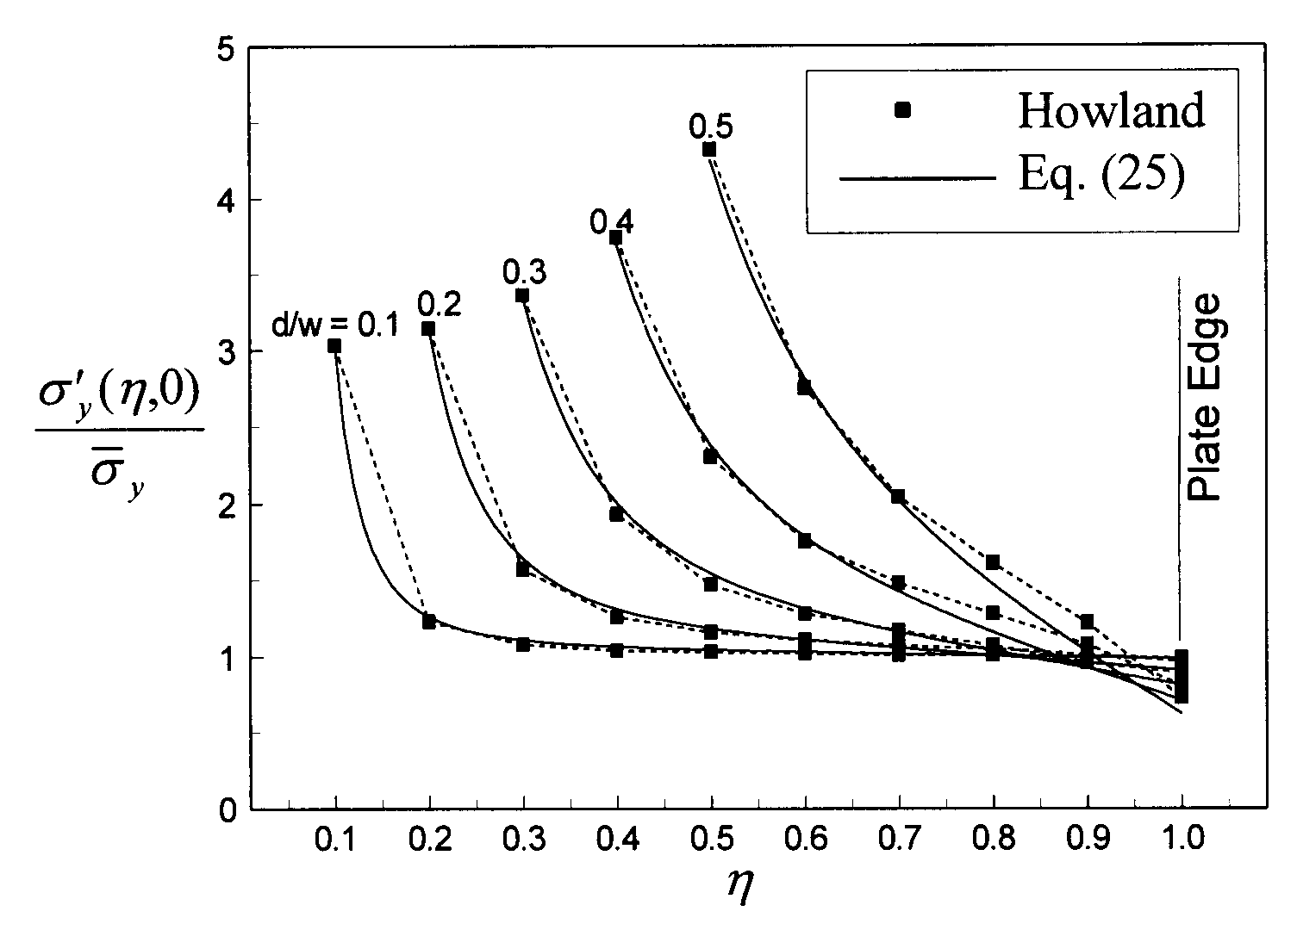
b)
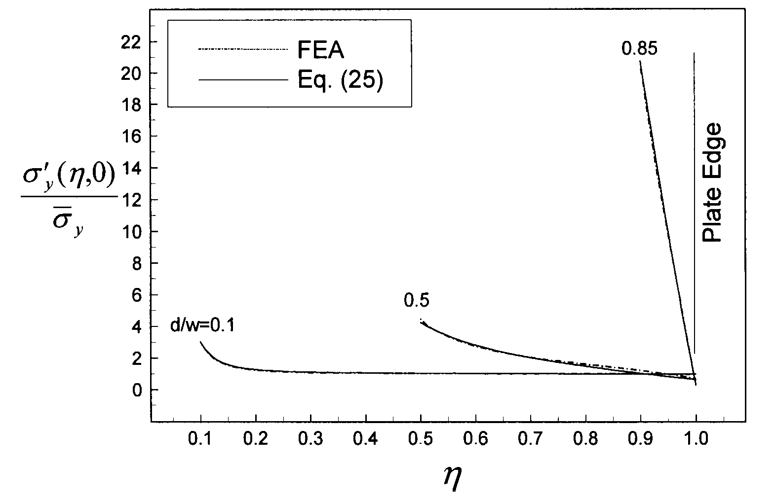
Fig.2. Comparisons of Eq.(25) and (a) Howland's solutions, (b) FEA solutions.

For an isotropic plate and a laminated composite with the same geometry under the same load, the force balance must be achieved between them. Another equation is expressed as
$$\begin{aligned}\int{\left[\frac{σ_{y}^{'}(x,0)}{{\bar{σ}}_{y}}+b_{1}{\left(\frac{R}{w2}\right)}^{q}{\left(\frac{x}{w2}\right)}^{−q}+b_{2}{\left(\frac{R}{w2}\right)}^{\left(q+2\right)}{\left(\frac{x}{w2}\right)}^{−\left(q+2\right)}\right]}\text{dx}=\int{\frac{σ_{y}^{'}(x,0)}{{\bar{σ}}_{y}}\text{dx}}, \\ ⇒\int{\left[b_{1}R^{q}x^{−q}+b_{2}R^{\left(q+2\right)}x^{−\left(q+2\right)}\right]}\text{dx}=0\text{.}\end{aligned}$$
(31)
Evaluate the integral of Eq.(31):
$\left(q+1\right)b_{1}\left[β^{\left(q−1\right)}−1\right]+\left(q−1\right)b_{2}\left[β^{\left(q+1\right)}−1\right]=0\text{.}$ (32)
Solving Eqs.(30) and (32) yields
$\begin{aligned}b_{1}=\frac{−\left(q−1\right)Y\left[β^{\left(q+1\right)}−1\right]}{\left(q+1\right)\left[β^{\left(q−1\right)}−1\right]−\left(q−1\right)\left[β^{\left(q+1\right)}−1\right]}, \\ b_{2}=\frac{\left(q+1\right)Y\left[β^{\left(q−1\right)}−1\right]}{\left(q+1\right)\left[β^{\left(q−1\right)}−1\right]−\left(q−1\right)\left[β^{\left(q+1\right)}−1\right]}\text{.}\end{aligned}$ (33)
Substituting Eqs.(25) and (33) into Eq.(27) gives the approximation of axial stress distribution for laminated composites:
$\begin{aligned}\frac{σ_{y}(η,0)}{{\bar{σ}}_{y}}=\frac{1}{2}\left\{\frac{1+β^{2}η^{−2}}{1−β}+\frac{2κ^{''}}{Δ}[\left(−4β^{4}+3β^{2}+β^{−2}\right)+\text{12}\left(β^{2}−1\right)η^{2}+\right. \\ \left.3\frac{\left(β^{2}−β^{6}\right)}{η^{4}}]\right\}+Y\frac{\left(1−q\right)\left[β^{\left(q+1\right)}−1\right]β^{q}η^{−q}+\left(q+1\right)\left[β^{\left(q−1\right)}−1\right]β^{\left(q+2\right)}η^{−\left(q+2\right)}}{\left(q+1\right)\left[β^{\left(q−1\right)}−1\right]−\left(q−1\right)\left[β^{\left(q+1\right)}−1\right]}\text{.}\end{aligned}$ (34)
When , Eq.(34) gives the best approximation for the most laminated composites with various d/w ratios, lay-ups, and material systems; for lamina (IM6/3501-6, , for example) or laminates such as (IM6/3501-6, , for example) with , is much more appropriate for Eq.(34).
The comparisons of Eq.(34) and FEA solutions [30] for various d/w ratios, lay-ups, and material systems are plotted in Fig.3. The material properties are summarized in Table 1 for reference. As shown in Fig.4, the experimental results [31] are also compared with Eq.(34) and FEA solutions for IM6/3501-6 laminates. The very good agreement between Eq.(34), FEA results, and test results is observed.
By comparing Figs.2 and 3, it is evident that the axial stress distribution for isotropic plate and laminated composite has the same trend as d/w ratio increases. It is also substantiated by the experimental investigations, that the notched strength of the laminated composite drops as the SCF rises due to the increased d/w ratio. For the same d/w ratio and the same material system, the infinite-width SCF, the finite-width SCF, and the axial stress distribution for laminated composites are strongly dependent on the lay-up. In Fig.3, for the same d/w ratio and the material system, although the SCF of the lamina or the cross-ply laminate is higher than other laminates, but the axial stress tends to recover to the uniform tensile load much faster than other laminates do. This behavior may lead the lamina or the cross-ply laminate to have higher notched strength than that of other laminates with the same d/w ratio, the same material system, and the same number of plies. It is because for the same d/w ratio, the lamina or cross-ply laminate has more material with much lower axial stress gradient and thus, much more load carrying capacity.

6. CONCLUSIONS

The expressions of the finite-width axial stress distribution for notched isotropic plates and laminated composites, respectively, are obtained analytically. The analytical approximations are validated by comparing with FEA solutions and experimental investigations. It is highly expected that the analytical approximations may help establish the new notched strength prediction model of the laminated composites.

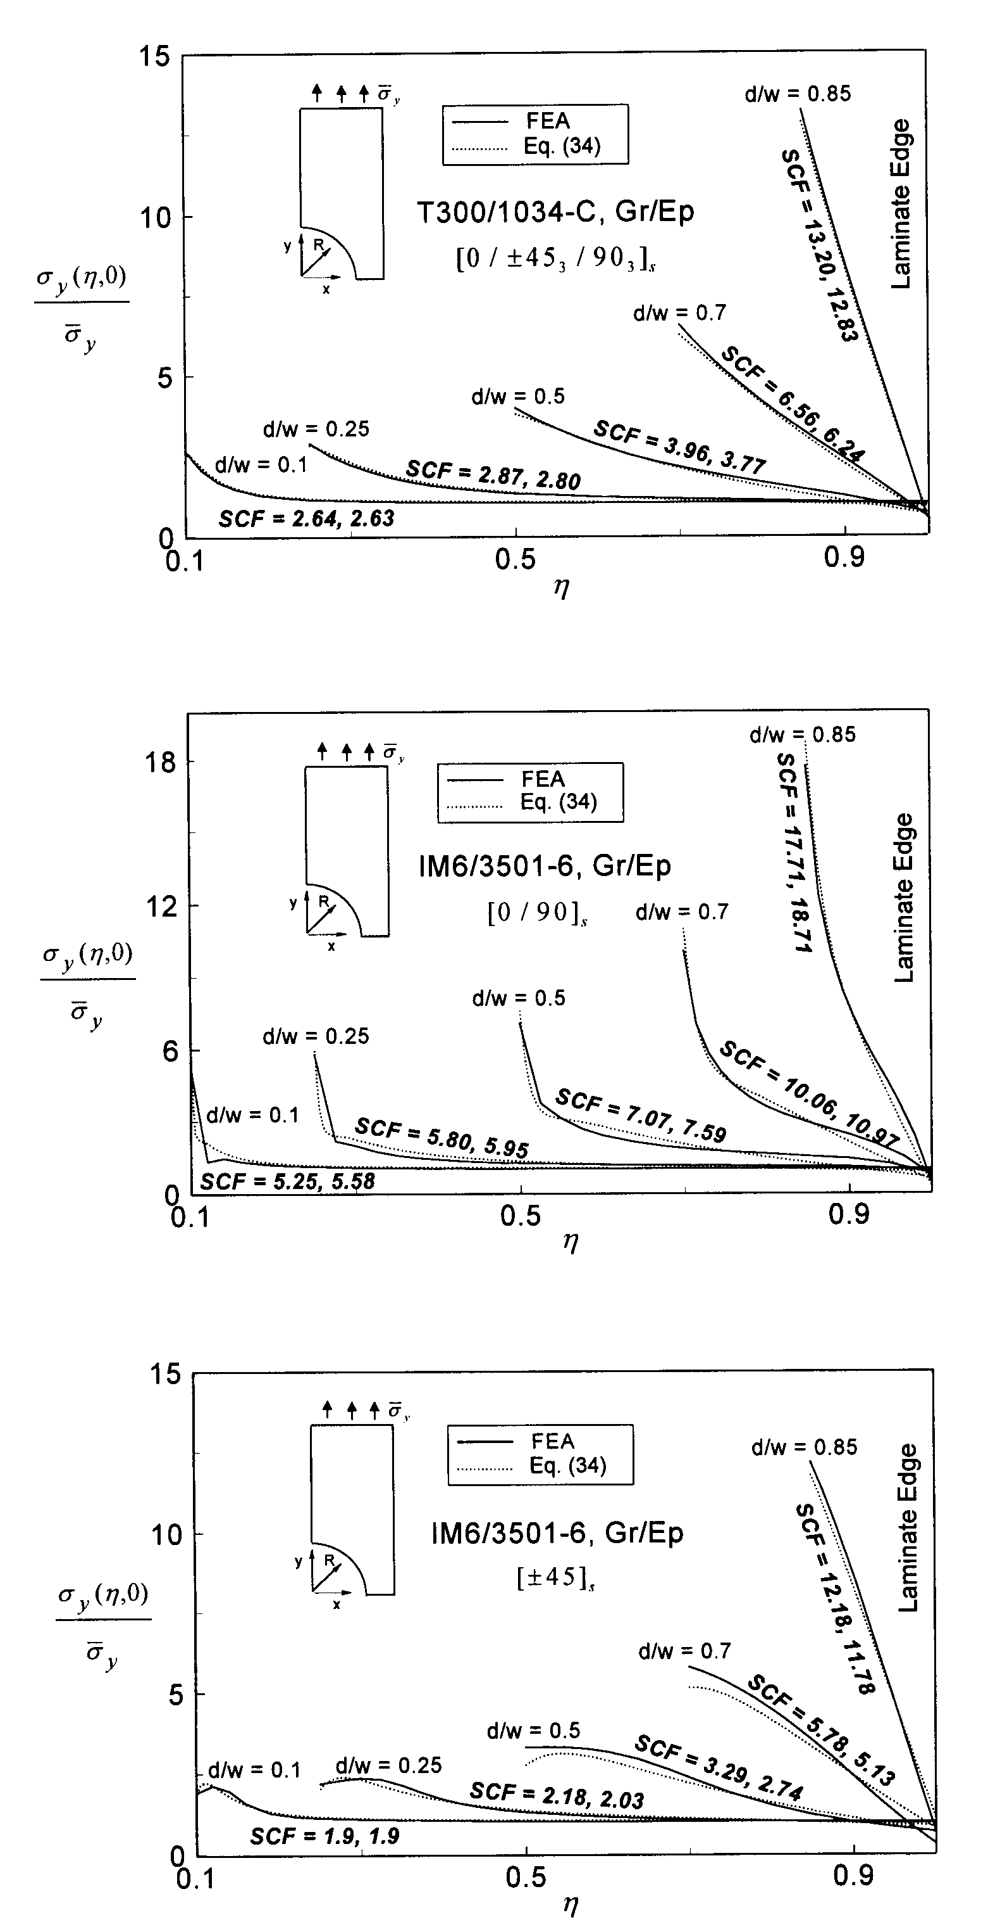
Fig.3. Comparison of Eq.(34) and FEA results for various d/w ratios, lay-ups, and material systems.
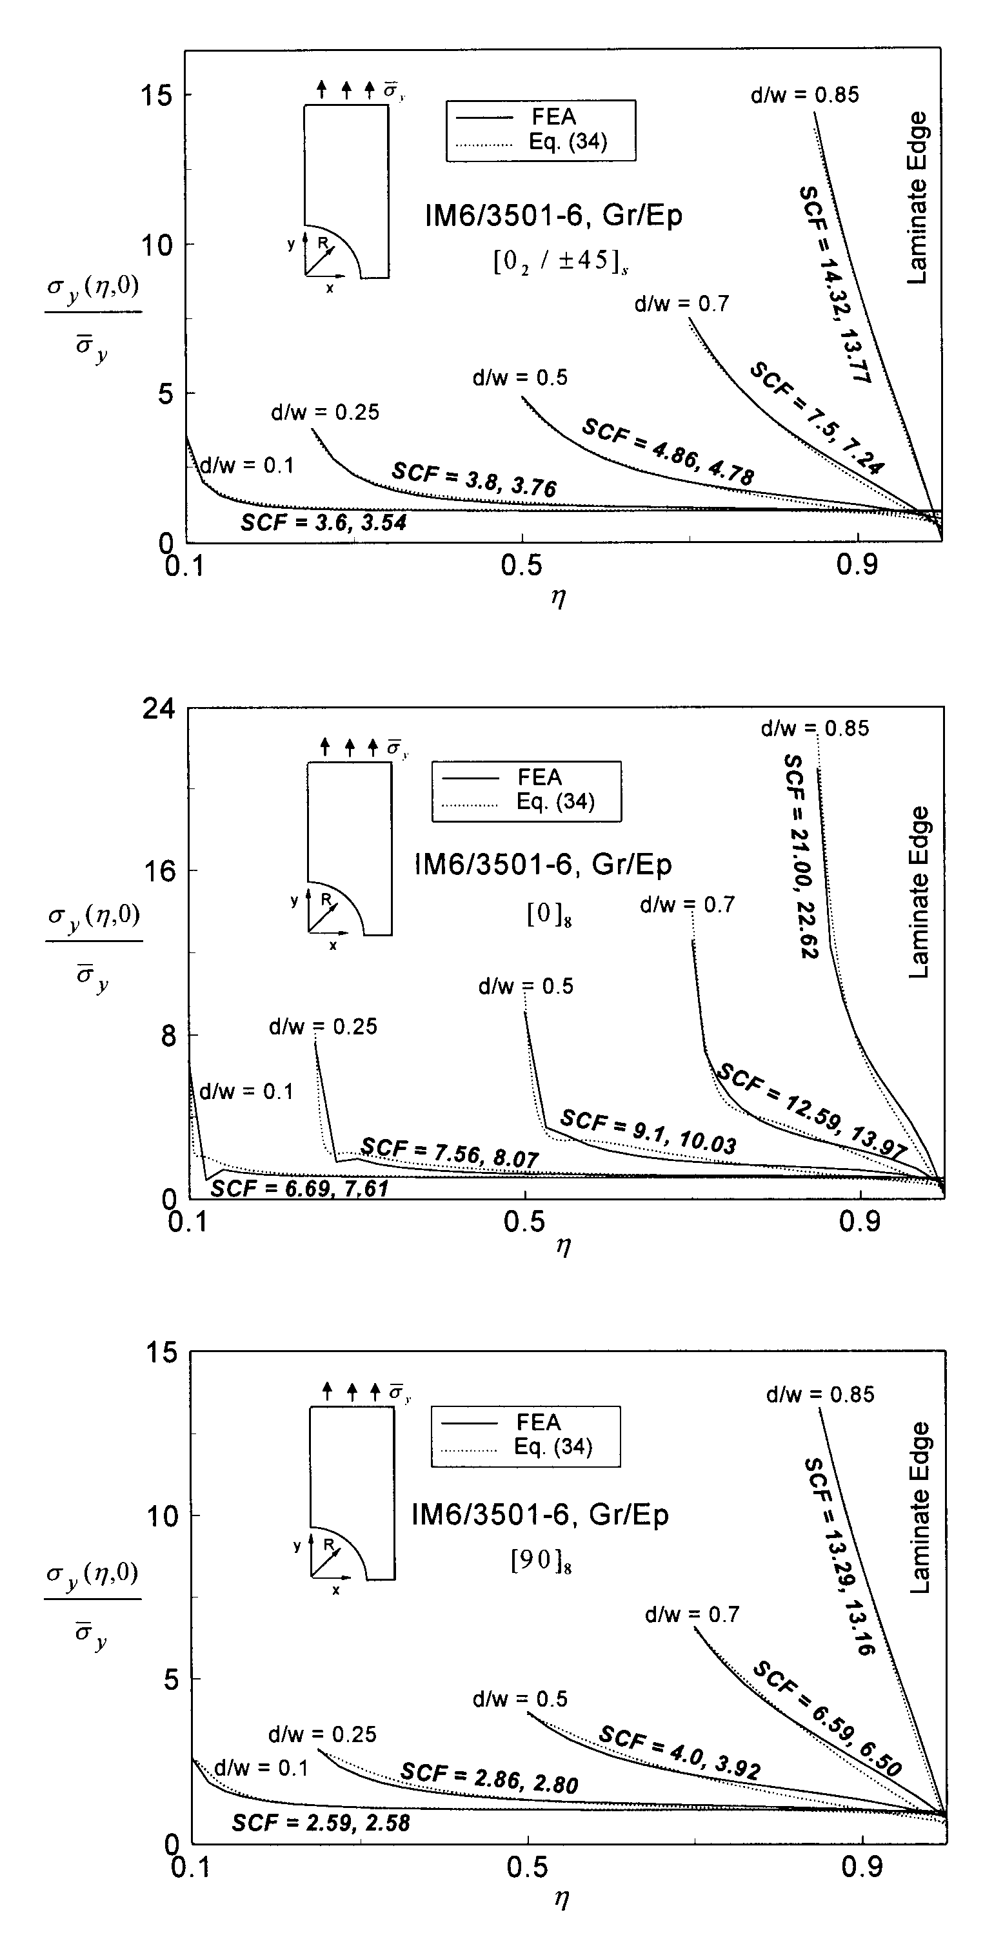
Fig.3. – Continued. Comparison of Eq.(34) and FEA results for various d/w ratios, lay-ups, and material systems.
Table 1.
Material Properties for IM6/3501-6 and T300/1034-C

Material System
IM6/3501-6, Gr/Ep | 24.80 | 1.40 | 0.70 | 0.325
T300/1034-C, Gr/Ep | 21.30 | 1.65 | 0.89 | 0.300

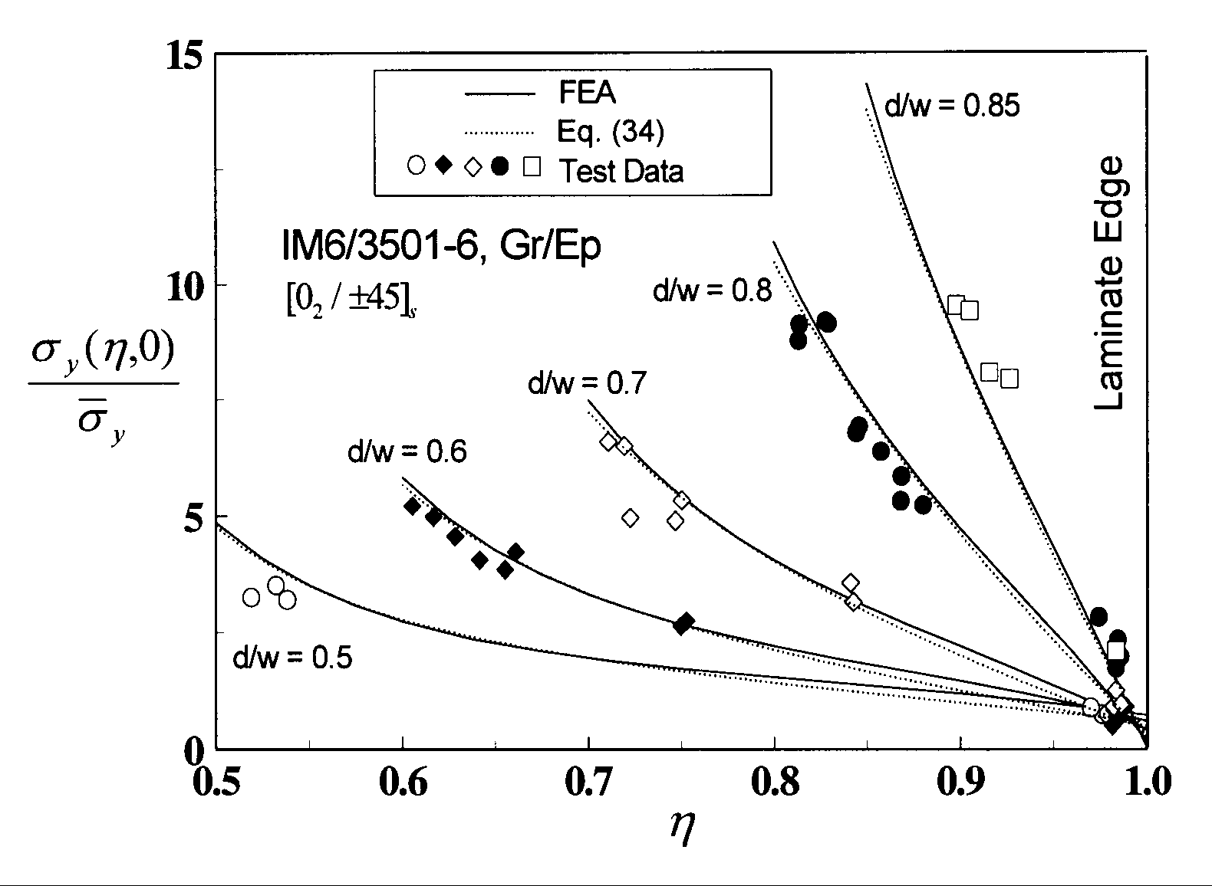
Fig.4. Comparisons of Eq.(34), test data, and FEA results for IM6/3501-6, laminate with various d/w () ratios.

REFERENCES

- S.P.Timoshenko, J.N.Goodier Theory of Elasticity. 3rd edition, McGraw-Hill Book Company, 1970.
- R.C.J.Howland On the Stresses in the Neighbourhood of a Circular Hole in a Strip Under Tension. Trans.Roy.Soc. (London), ser.A, v.229, 1930, p.49.
- E.Sternberg, M.A.Sadowsky Three-Dimensional Solution for the Stress Concentration Around a Circular Hole in a Plate of Arbitrary Thickness. J.Applied Mechanics, 1949, p.27.
- S.G.Lekhnitskii Anisotropic Plates. Gordon and Breach, 1968.
- G.N.Savin Stress Concentration Around Holes. NASA-TT-F-607, 1968.
- J.M.Whitney, H.J.Konish Approximate Stresses in an Orthotropic Plate Containing a Circular Hole. J.Composite Materials, v.9, 1975, p.157.
- W.L.Ko Stress Concentration Around a Small Circular Hole in the HiMAT Composite Plate. NASA-TM-86038, December 1985.
- J.M.Ogonowski Analytical Study of Finite Geometry Plates with Stress Concentrations. AIAA/ASME/ASCE/AHS 21st. SDM Conference, Seattle, Washington, 1980, p.694.
- E.Madenci, L.Ileri, J.N.Kudva Analysis of Finite Composite Laminates with Holes. Int.J.Solids Structures, v.30, N6, 1993, p.825.
- G.C.Sih, S.E.Hsu Stress and Strength Analysis of Finite Composite Laminates with Unloaded Fastener Holes. Proceedings of an International Conference, Taipei, Taiwan, 1986, p.611.
- Chu-Cheng Ko, Chien-Chang Lin Method for Calculating the Interlaminar Stresses in Symmetric Laminates Containing a Circular Hole. AIAA Journal, v.30, N1, 1992, p.197.
- S.Tang Interlaminar Stresses Around Circular Cutouts in Composite Plates Under Tension. AIAA Journal, v.15, N11, 1977, p.1631.
- Kai-Da Zhang, Charles E.S.Ueng A Simplified Approach for Interlaminar Stresses Around a Hole in Laminates. Journal of Composite Materials, v.22, 1988, p.192.
- M.-H.R.Jen, Y.S.Kau, J.M.Hsu Interlaminar Stresses in a Centrally Notched Composite Laminate. Int.J.Solids Structures, v.30, N21, 1993, p.2911.
- S.C.Tan Finite-Width Correction Factors for Anisotropic Plate Containing a Central Opening. J.Composite Materials, v.22, 1988, p.1080.
- R.B.Pipes, N.J.Pagano Interlaminar Stresses in Composite Laminates Under Uniform Axial Extension. J.Composite Materials, v.4, 1970, p.538.
- J.M.Whitney The Effect of Boundary Conditions on the Response of Laminated Composites. J.Composite Materials, v.4, 1970, p.192.
- A.H.Puppo, H.A.Evensen Interlaminar Shear in Laminated Composites Under Generalized Plane Stress. J.Composite Materials, v.4, 1970, p.204.
- E.F.Rybicki Approximate Three-Dimensional Solutions for Symmetric Laminates Under Inplane Loading. J.Composite Materials, v.5, 1971, p.354.
- S.Tang A Boundary Layer Theory - Part I: Laminated Composites in Plane Stress. J.Composite Materials, v.9, 1975, p.33.
- S.Tang, A.Levy A Boundary Layer Theory - Part II: Extension of Laminated Finite Strip. J.Composite Materials, v.9, 1975, p.42.
- A.S.D.Wang, F.W.Crossman Some New Results on Edge Effect in Symmetric Composite Laminates. J.Composite Materials, v.11, 1977, p.92.
- S.S.Wang, I.Choi Boundary-Layer Effects in Composite Laminates: Part I - Free-Edge Stress Singularities. J.Applied Mechanics, v.49, 1982, p.541.
- S.S.Wang, I.Choi Boundary-Layer Effects in Composite Laminates: Part II - Free-Edge Stress Solutions and Basic Characteristics. J.Applied Mechanics, v.49, 1982, p.549.
- C.Kassapoglou, P.A.Lagace An Efficient Method for the Calculation of Interlaminar Stresses in Composite Materials. Transaction of the ASME, v.53, 1986, p.744.
- W.S.Chan, O.O.Ochoa Delamination Characterization of Laminates Under Tension, Bending and Torsion Loads. Computational Mechanics, v.6, 1990, p.393.
- D.K.Shah, W.S.Chan Delamination Characteristics Around Hole in Laminates With Softening Strip. Journal of Aerospace Engineering, v.6, N2, 1993, p.199.
- R.E.Peterson Stress Concentration Design Factors. John Wiley and Sons, 1953.
- W.S.Chan, C.J.Chou Effects of Delamination and Ply Fiber Waviness on Effective Axial and Bending Stiffnesses in Composite Laminates. Composite Structures, v.30, 1995, p.299.
- Fung-En Harn Notched Strength of Graphite/Epoxy Laminates With Various Hole Sizes. Ph.D. Dissertation, the University of Texas at Arlington, Arlington, Texas, 1997.
- Fung-En Harn, Wen S.Chan Notched Strength of Graphite/Epoxy Laminates With Various Hole Sizes. Proceedings of ETCE’98, Symposium on Composite Materials, Design and Analysis, ASME Conference, Houston, Texas, 1998.

Поступила в редакцию 14 октября 1999 года.

