ELASTO-PLASTIC ANALYSIS OF SANDWICH BEAMS
BY JOINT ELEMENTS

L.C.Sousa, A.J.M. Ferreira and J.M.A.C.Sá

Faculdade de Engenharia da Universidade do Porto, Rua Dr. Roberto Frias,
4200 Porto, Portugal

ABSTRACT

Sandwich structures are usually analysed by different methods of finite element representation. Most of them apply an ideal interface that will not collapse during deformation. As the core and the adhesive are weaker than the skins, it is expected that the performance of the adhesive will play a significant role. In this paper is proposed an analysis of sandwich beams that considers the plasticity of the core and of the skin. The 2D analysis considers an elasto-plastic formulation based on an associative formulation. The inclusion of a joint element at the skin-core interface is also proposed. This element may collapse plastically, and debonding will occur. Results so far illustrate the need of such a refined analysis.

SYMBOLS:
A | - transformation matrix
B | - strain displacement matrix
D | - constitutive matrix
E | - young’s modulus
G | - shear modulus
 | - adhesivee thickness
 | - structure thickness
K | - stiffness matrix
L | - joint length
N | - shape function matrix
P | - applied loads
 | - nodal applied loads
 | - displacment vector in local coordinates
v | - displacment vector in local coordinates
 | - total external work
 | - total internal work
x, y | - global coordinates
 | - orientation angle of joint element
 | - strain vector
 | - shear strain limit
 | - normal strain
 | - shear strain
 | - normal delamination strain
ν | - poisson coefficient
 | - normal stress
 | - yield stress
 | - stress tensor
 | - shear stress
 | - local coordinates

1. INTRODUCTION

Sandwich structures are an excellent example of combination of materials, in order to create a better structure than that one that could be created with the materials alone [1-5].
The sandwich structure consists, generally, of the bonding of stiff and strong faces (skins) to a weak, soft and light core material. Skin materials can be chosen from metals, particularly aluminium, composites or wood. Core materials range from balsa wood, honeycombs to polymeric foams.
The skin and the core materials form together a low-weight, high stiffness, that is well insulated thermally and for sound.
Due to the nature of the sandwich construction, a layer of adhesive bonding has to be provided, in order to connect skins and core, and to transfer loads, mainly by shear, between skins and core.
The adhesive interface is therefore of great influence to the overall behaviour of the structure. Elastic and elasto-plastic materials are used for this purpose, typically of polymeric nature. In this paper a joint element formulation is used to simulate the behaviour of the adhesive bonding
In order to test the performance of the joint element we choose an example of a single-lap joint and compare the numerical solution with the analytical one obtained by Erdogan [6].
The objective of this paper is to show that this analysis method is capable of simulating the mechanical and structural behaviour of a sandwich structure (beam), incorporating the performance of the adhesive; a finite element analysis of a two-dimensional sandwich beam, with interface elements is proposed.
The beam model is illustrated in figure 1 and 2, where the skins and the core are modelled by 2D plane stress elements and the interface being modelled by joint elements.
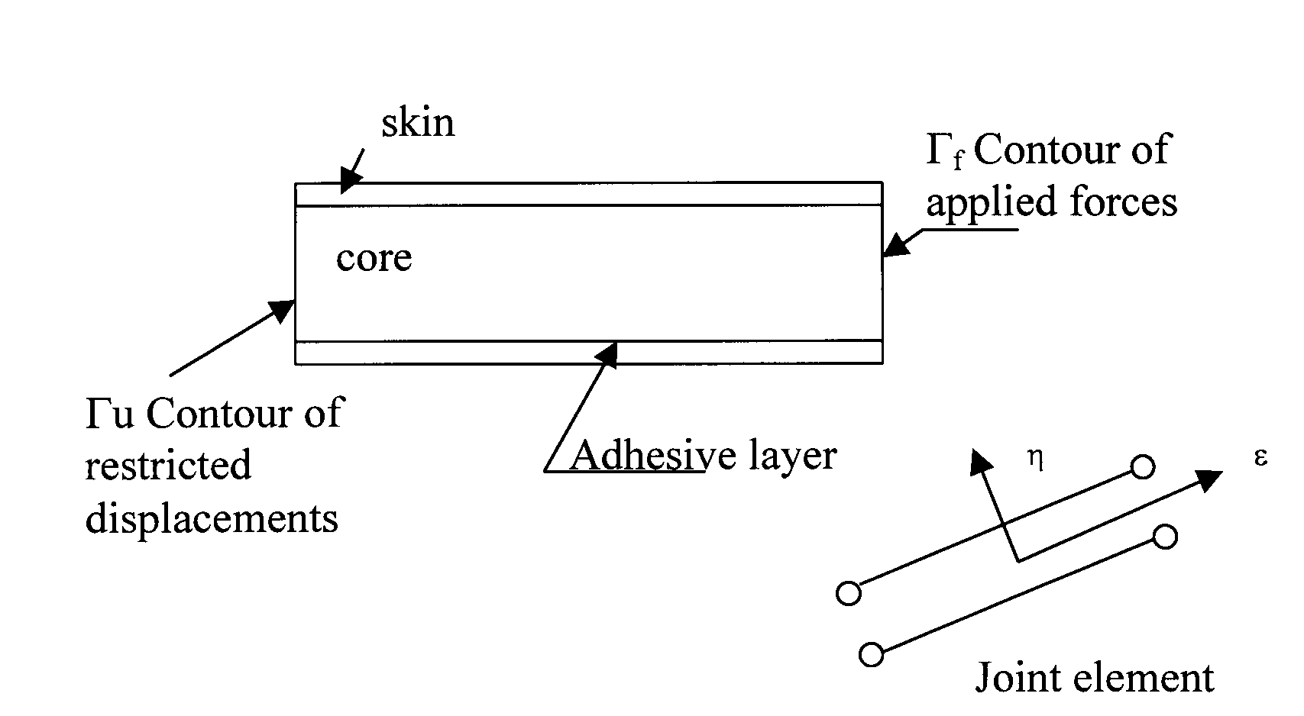
Figure 1. Sandwich structure model with an illustration of the joint (interface) element.
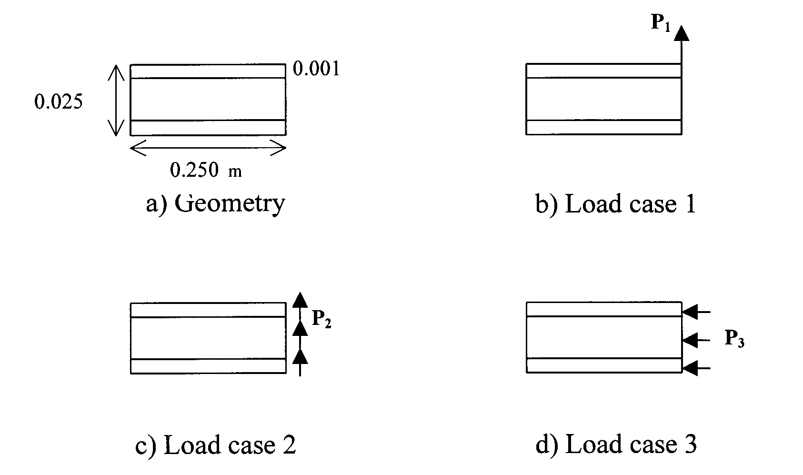
Figure 2. Sandwich structure model - load cases.

An elasto-plastic analysis has been performed, based on an associative flow rule and on a total Lagrangian formulation. The evolution of the damaged interface, as the stresses at the interface are exceeding the yield stresses, is performed.
Some examples are discussed. The results are promising to a further investigation of the behaviour of sandwich beams, plates or shells, and its coupling with the plasticity/fracture of the adhesive.

2. THE JOINT ELEMENT

Four node plane elements are used and a non-linear behaviour is permitted by the use of any yield criterion.
A layer of interface elements with coincident nodes [7-11] of zero thickness type is used to model the contact and sliding between the two different materials and to simulate the behaviour of the adhesive.

2.1. Stress-strain relationships.

Initially, these elements get an equivalent normal and shear stiffness to model the joint in its elastic stage, but when the tensile strength is reached, bond failure takes place and a crack opens up.
The interface elements must represent the elastic normal and shear modulus of the joint and set a relation between stresses and relative displacement across the interface; with interface elements for 2D analysis, this relation is given by a constitutive matrix D that links the normal stress σ_{n} and shear stress τ_{s} to the relative normal displacement Δu_{n} and relative tangential displacement Δu_{t} across the interface:
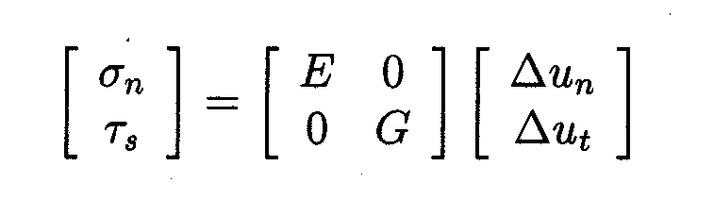 (1)
When σ_{n} reaches the tensile strength the crack is initiated and the stiffness modulus are changed according to a constitutive model for the crack; in this study at this stage the normal stress σ_{n} and the tangential shear τ_{s} stress are both set to zero as the corresponding elastic modulus E_{n} and G_{t}, figure 3.
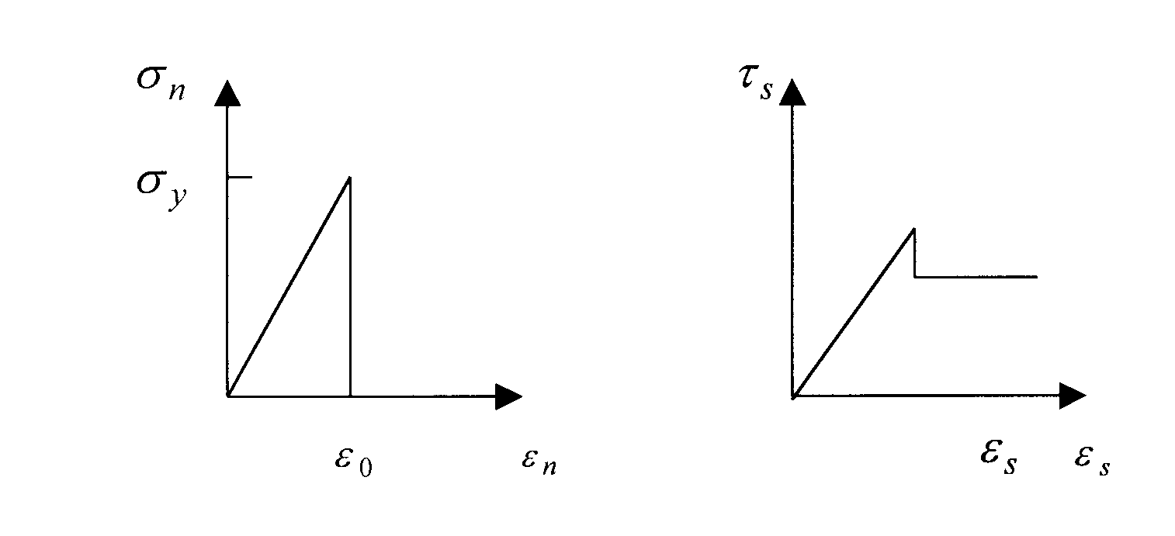
Figure 3. Non linear behaviour and failure criterion of joint elements.

Otherwise if no failure has occurred in the interface (σ_{n} < σ_{y}) the shear behaviour in the tangential direction is elastic to a certain stress limit after which boundary sliding is assumed to occur; in this case a tension-softening model is adopted for the behaviour in the tangential direction. The tangential shear stress does not drop to zero, neither does remain at a constant level but it decreases gradually to some residual value representing the effect that the resistance will decrease to a residual level.
After collapse of the joint element if the skin is approaching the core (Δu_{n} < 0), the constitutive matrix is changed by imposing the same normal displacement to both materials. This restraint is treated by a penalty method [7-9] and the constitutive matrix becomes:
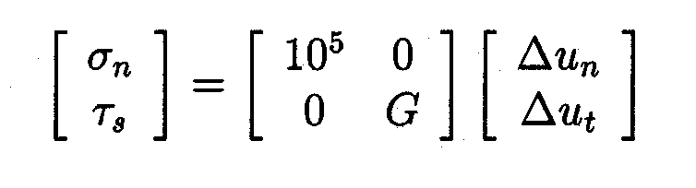 (2)

2.2. Finite element formulation.

The relative displacement vector Δu in global coordinates may be calculated for any point as follows:
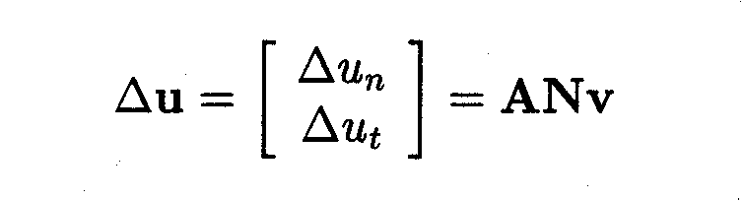 (3)
where v is the displacement vector in local coordinates as shown in figure 4
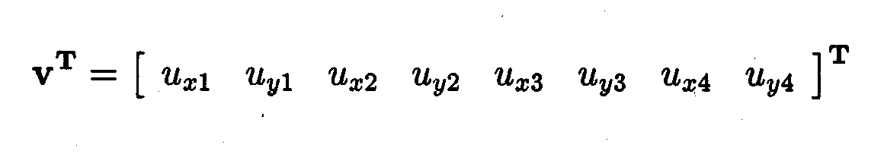 (4)
and A is the transformation matrix at each point
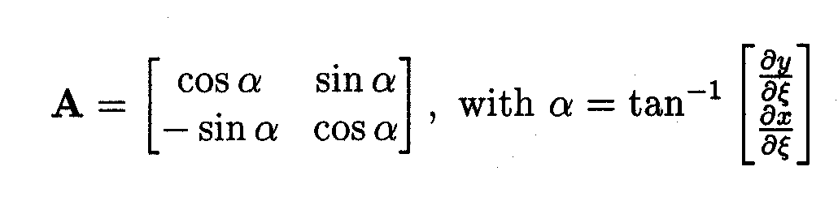 (5)
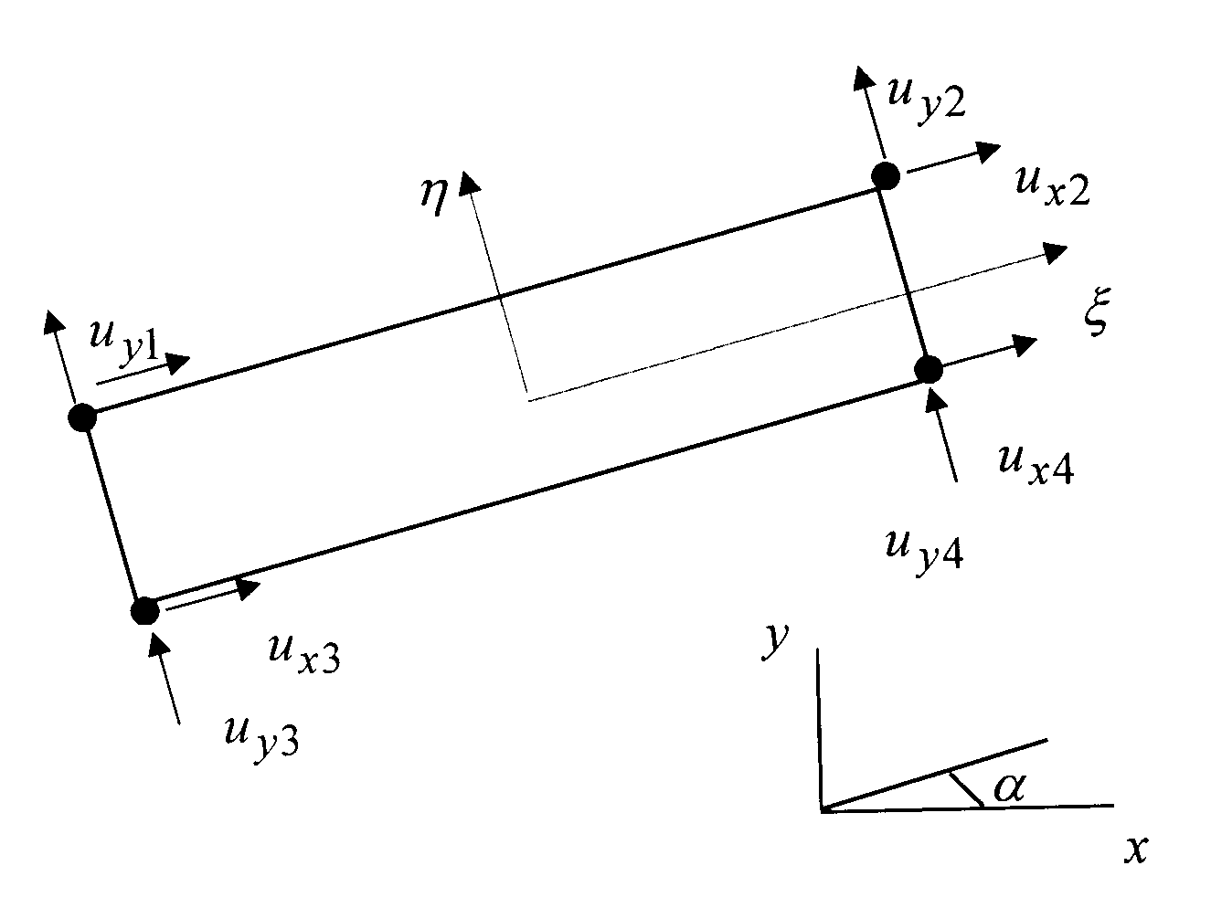
Figure 4. Four node joint elements.

The matrix N is given by
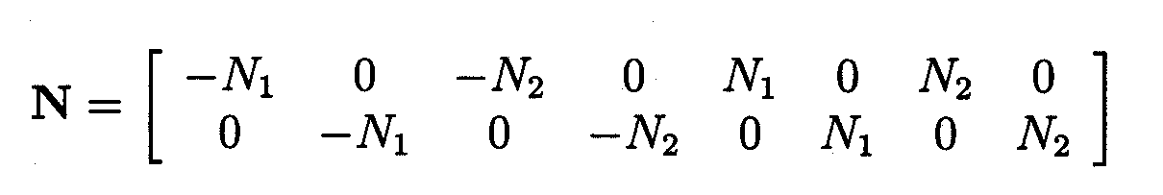 (6)
where N_{i} are the standard linear interpolation functions.
Considering that the thickness of the joint element (same as the adhesive thickness) is t the vector strain is defined as
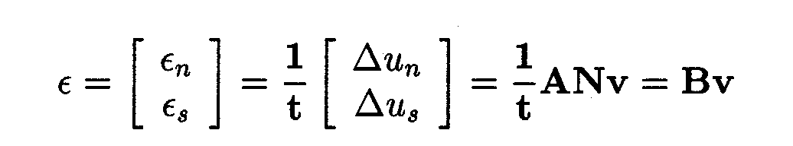 (7)
The total external and internal virtual work are given by
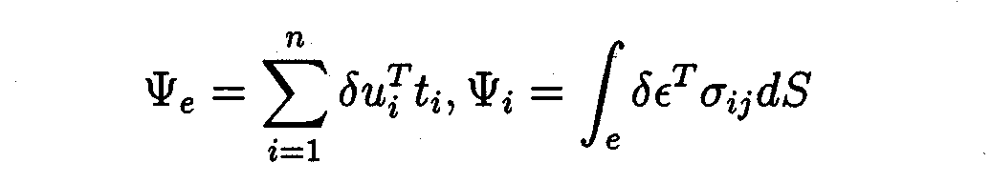 (8)
As by the principle of the virtual work the total internal work is equal to the total external work we have
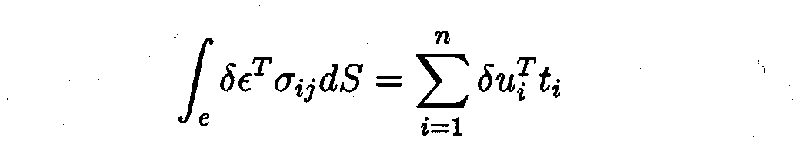 (9)
For a joint element assuming that no external forces t_{i} are applied, by equations (1), (3), and (7) we get
 (10)
and by the above expressions the stiffness matrix is given by
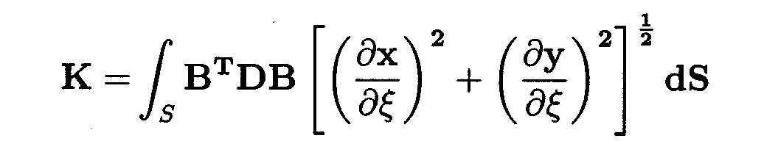 (11)
Interface zero thickness elements possess certain deficiencies in particular an oscillatory type of response due to excessively large stiffness parameters, high traction gradients, insufficient mesh refinement and inappropriate integration schemes.
In linear interface elements the use of Newton-Cotes or Lobatto integration schemes results in smooth stress profiles [12-14] and with fine meshes the performance is good especially when compared to the results obtained from Gaussian integration.

3. NUMERICAL EXAMPLE

In the first example a single lap joint is considered [6]. This is a joint of an epoxy-type adhesive bonding two stressed metal adherents aluminium and steel. The structure geometry and the material characteristics are shown in figure 5.

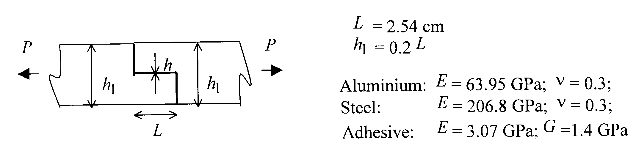
Figure 5. Structure geometry.

As the thickness h₁, h₂ and h are small compared to the other dimensions of the composite structure, the joint is analysed under conditions of plane stress. The interface (joint) elements model the adhesive layer connecting the skins to the core.
In figure 6 the finite element mesh with a refinement near the joint lap is illustrated and in figure 7 the shear stress obtained is compared with the analytical solution given by F. Erdogan et al. [2]. The results are in good agreement with the solution in [6].
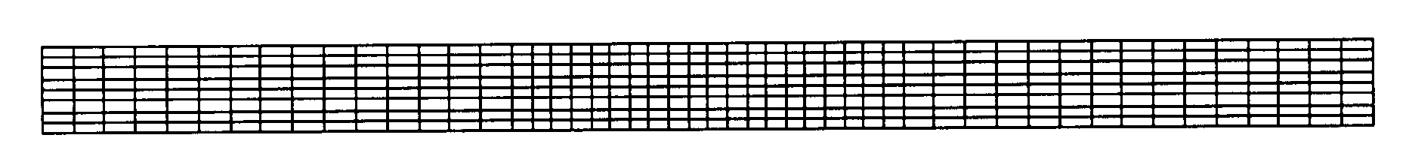
Figure 6. Finite element mesh.
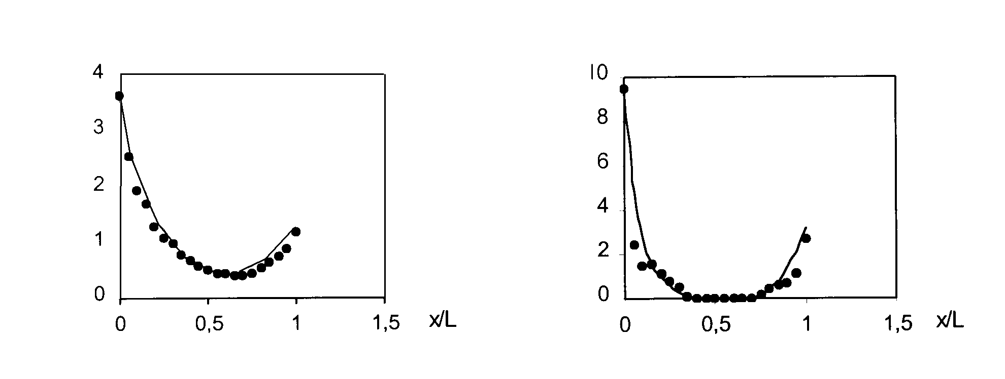
Figure 7. h=0.01 L; h=0.001 L
Shear stress /P/ analytical solution.
The second example is the simulation of a sandwich beam loaded with various forces and with different boundary conditions (figure 1 and 2). The 2D plane stress elements model both the skins and the core materials. The interface (joint) elements model the adhesive layer connecting the skins to the core. The finite element mesh is shown in figure 8.

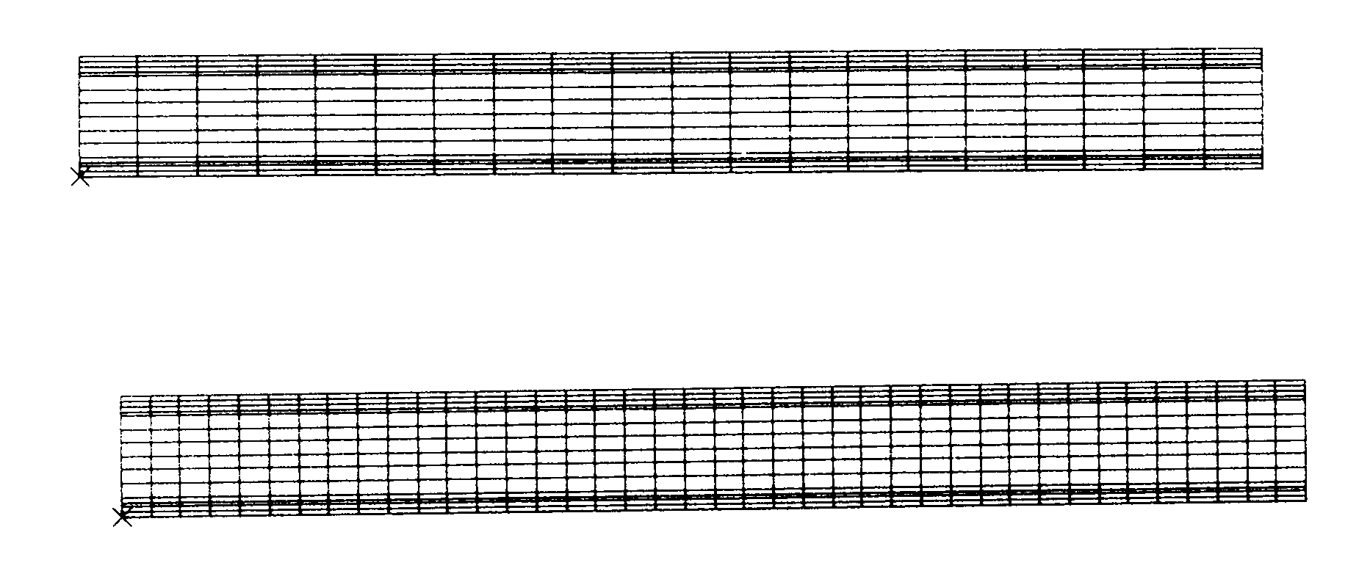
Figure 8. Initial finite element mesh and refined mesh for all load cases.

The material characteristics are as follows:
Aluminium: E = 70 GPa; ν = 0.3, σy=150 MPa
Core (PVC foam): E = 6.5 GPa; ν = 0.3, σy=20 MPa
Adhesive (epoxy): E = 3 GPa; G =1.2 Gpa, τy=0.7 MPa
The shear strain limit after which boundary sliding is assumed to occur is equal to ε_{l} =2mm and the residual shear stress is considered to be half of the shear stress limit.
In figure 9 it is shown the deformed geometry corresponding to the first load case. In this case the load is applied only at the top of the upper skin, as in a mode I load. The crack opens due to the fact that the normal stress σn reaches the tensile strength of the adhesive. There are no appreciate differences between the deformed geometry of the initial mesh and refined mesh as the length of the crack is almost the same for the two meshes.

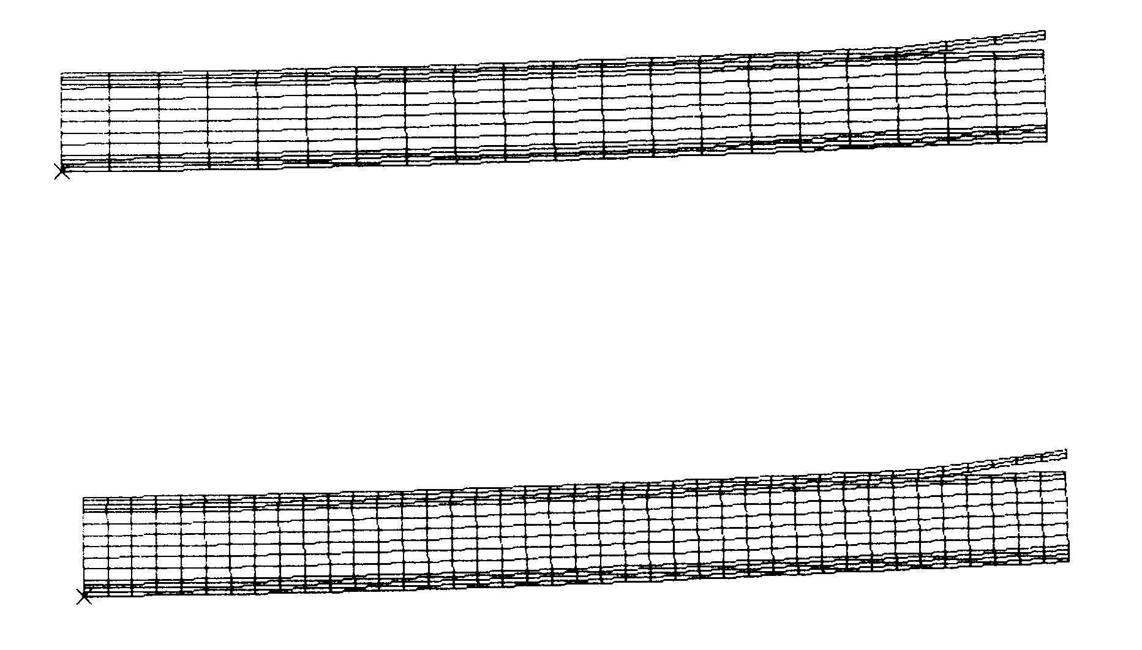
Figure 9. Deformed geometry for the first load case.
In figure 10 and 11 is illustrated the shear and the normal stresses along the lower and the upper joint, before the opening of the crack. In the figure 12 and 13 the same stresses are shown, corresponding to the deformed geometry, after the opening of the crack. For the refined mesh the normal stress is almost free of any oscillations so this analysis results in smooth stress profiles and the performance is better than the one given by the initial mesh.
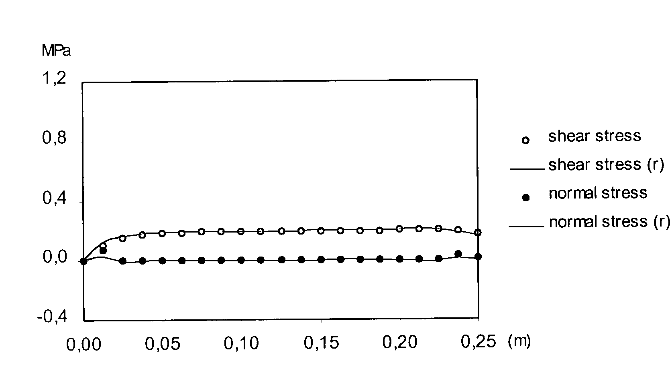
Figure 10. Normal and shear stress for the initial and refined mesh (r) along the lower joint, before the opening of the crack.

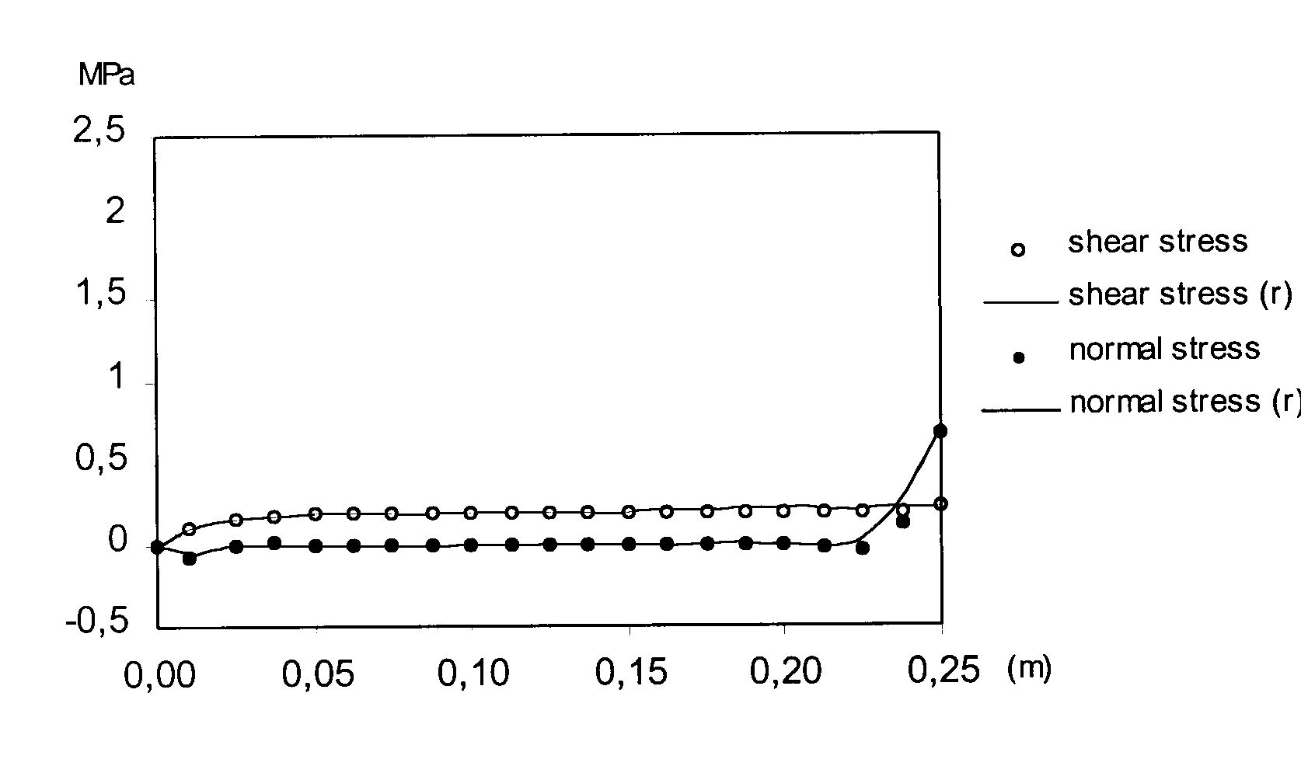
Figure 11. Normal and shear stress for the initial and refined mesh (r) along the upper joint, before the opening of the crack.
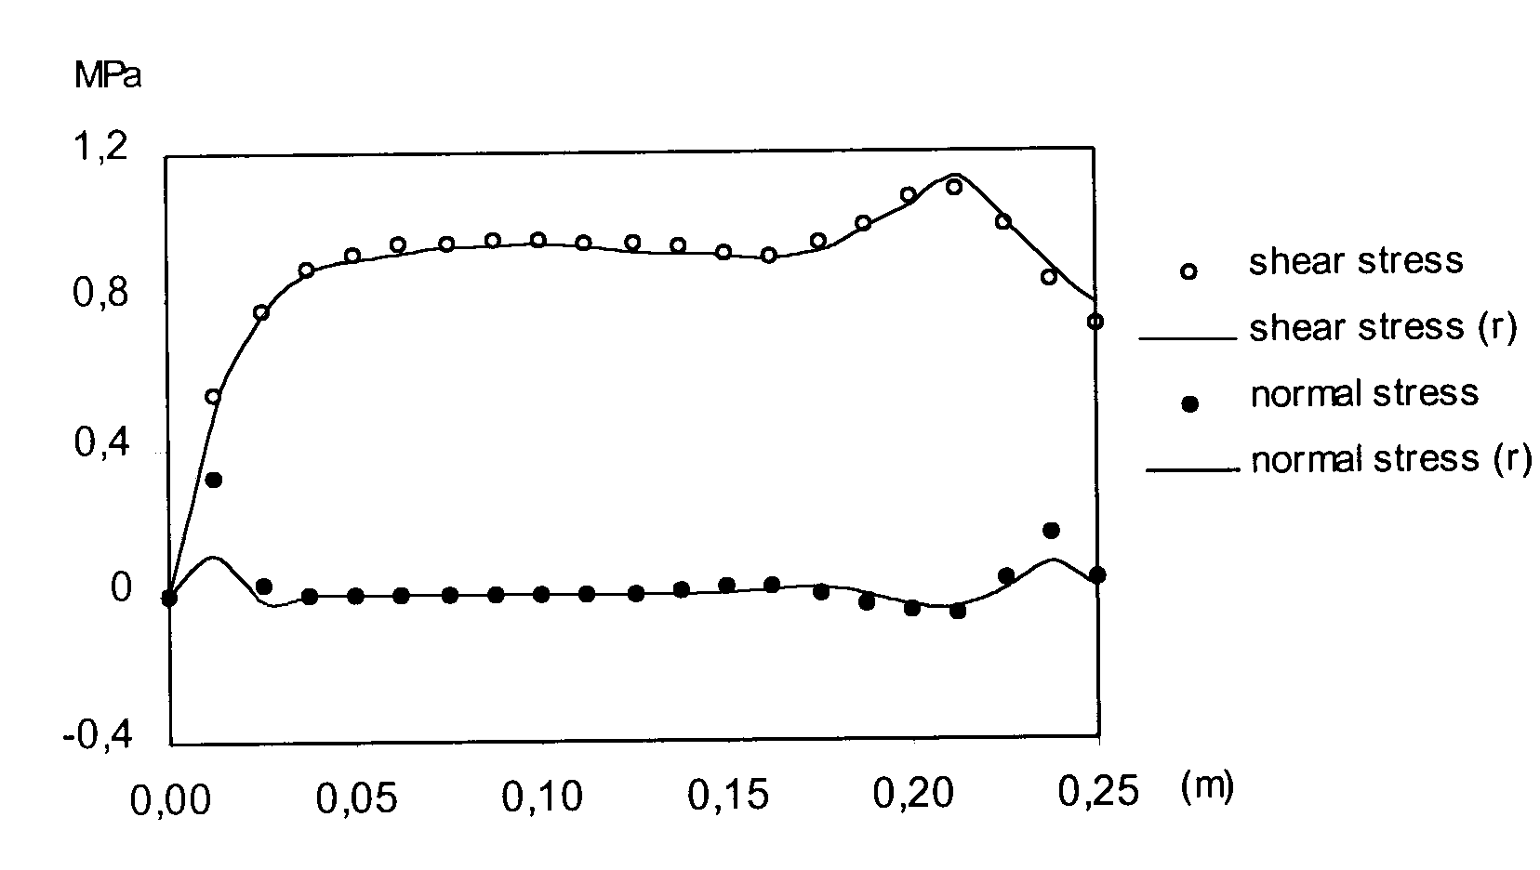
Figure 12. Normal and shear stress for the initial and refined mesh (r) along the lower joint, after the opening of the crack.

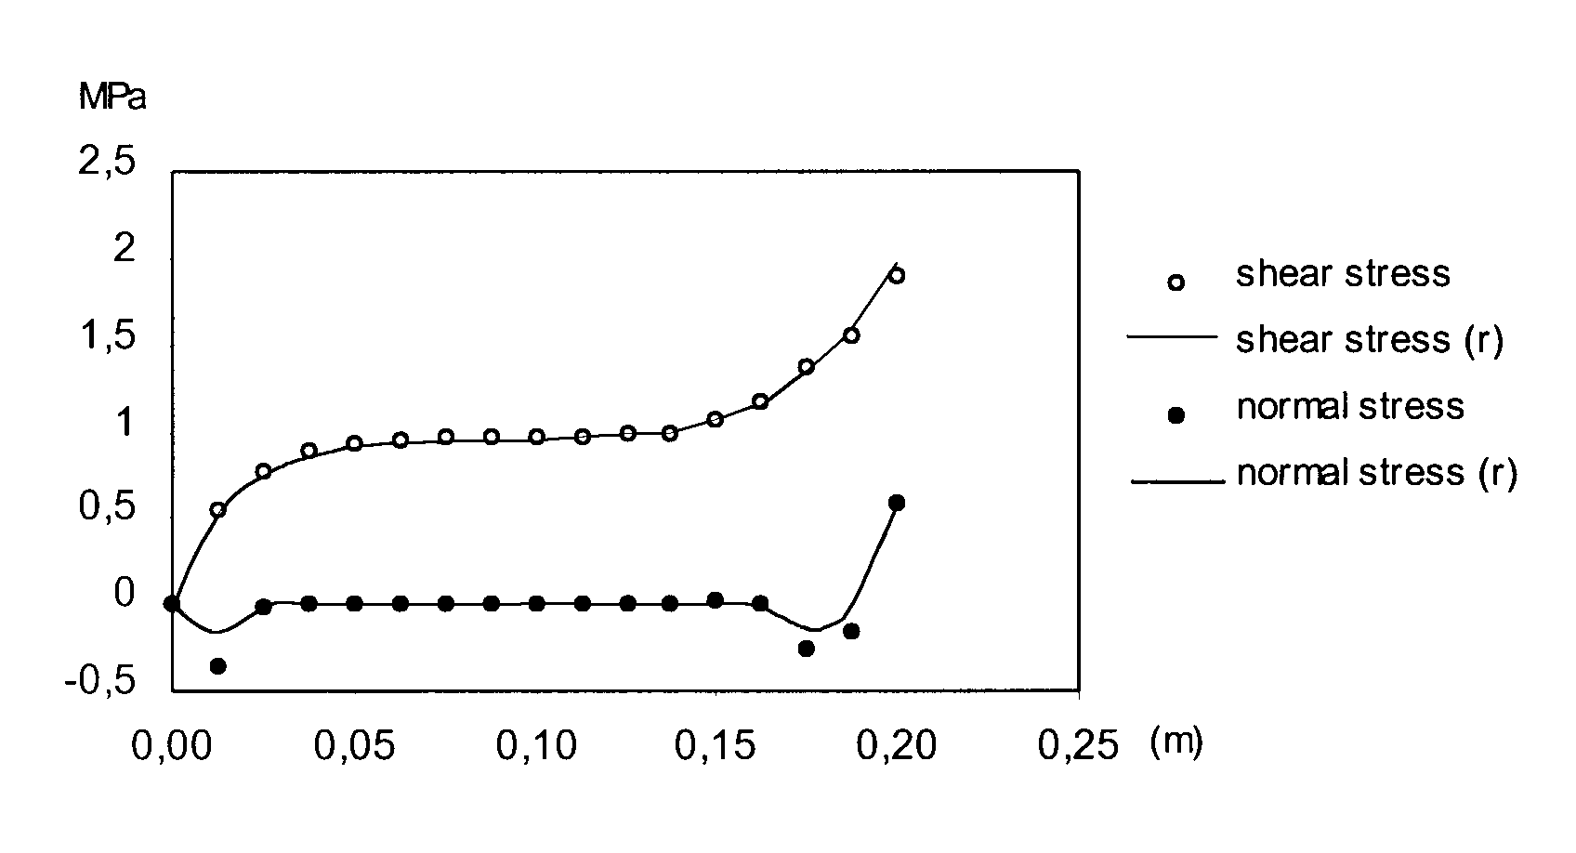
Figure 13. Normal and shear stress for the initial and refined mesh (r) along the upper joint, after the opening of the crack.

In figure 14 the deformed geometry of the same sandwich beam without joint elements simulating the adhesive is illustrated. In such an example the rupture of the adhesive bonding can’t be modelled and no mode I deformation is observed. In figure 15 is illustrated the deformed geometry for the second load case. In this load case the load is applied uniformly to the free bord, thus corresponding to a uniform shear load. As one can see, no mode I deformation is observed, although high shear stresses are induced in the skin-core interfaces. In figure 16 it is represented the shear and the normal stresses along the two skin-core interfaces, for the same total load. As neither the normal nor the shear stress reach the tensile strength of the adhesive no crack has been opened.
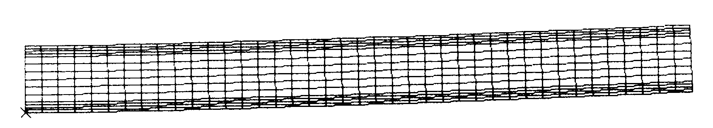
Figure 14. Deformed geometry for the first load case, without considering the joint elements (refined mesh).

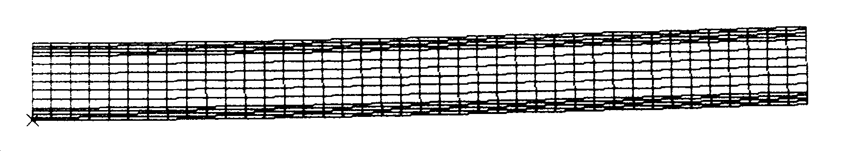
Figure 15. Deformed geometry for the second load case (refined mesh).

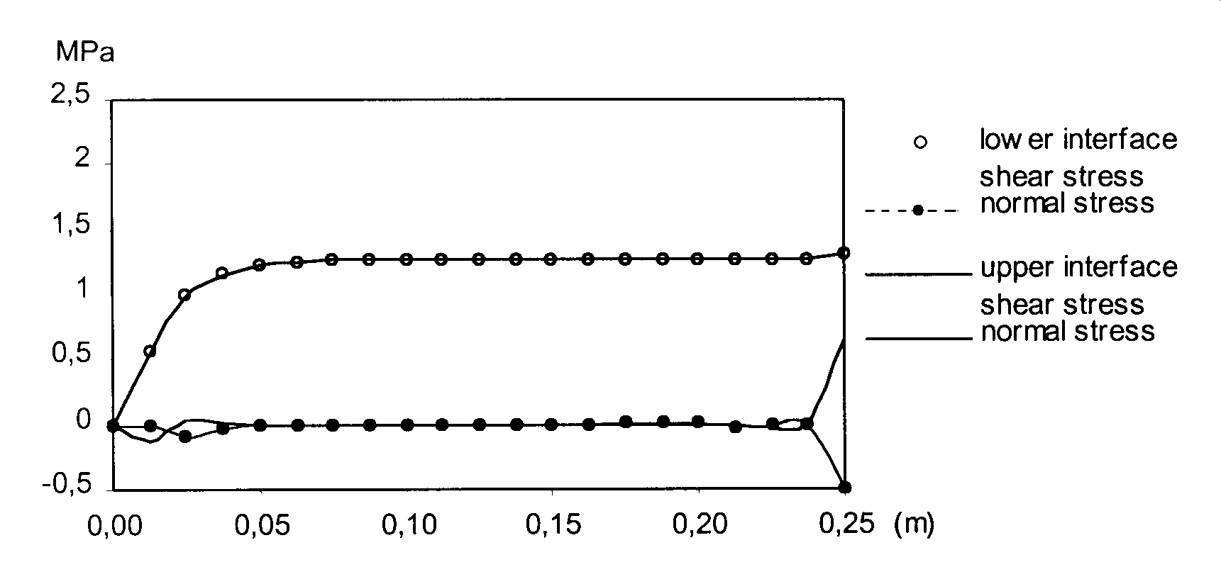
Figure 16. Normal and shear stress for the second load case.

4. CONCLUSIONS

In this paper the mechanical behaviour of sandwich beams was analysed through the use of interface and plane strain elements. The progressive damage of the adhesive bonding was evaluated under bending and compressive deformation modes. The non-linear behaviour of substrate materials (skins and core) is considered under an associative elasto-plastic formulation. The elasto-fragil behaviour of the adhesive is considered.
In the first example the mechanical behaviour of a single lap joint was analysed through the use of interface and plane stress elements and the shear stress obtained by the present simulation is in good agreement with the analytical results.
In the second example, the analysis of a sandwich beam, the progressive damage of the adhesive bonding was evaluated considering an elasto-fragil behaviour of the adhesive able to predict the rupture of the interface. The failure of the adhesive joint depends on the type of foam. In metallic foams it is expected that failure of the sandwich will be at the adhesive joint, while in polymeric foams, failure will take place at the foam itself.
The present formulation will be implemented in a general three-dimensional finite element code (solid and shell).

REFERENCES

- Gibson L. J. and Ashby M. F. Cellular Solids. Pergamon Press, 1988.
- Allen H.G. Analysis and design of structural sandwich panels. Pergamon Press, Oxford, 1969.
- Plantema, F. J. Sandwich Construction. John Wiley & Sons, New York, 1966.
- Zenkert, D. An Introduction to sandwich Constructions. EMAS, UK, 1995.
- Ferreira, A.J.M. Modelos numéricos para a análise de estruturas laminadas compósitas e sandwich. Ph.D. Thesis (in portuguese), Faculdade de Engenharia da Universidade do Porto, 1997.
- Erdogan F. and Ratwani M. Stress distribution in bounded Joints. Composite Materials, vol.5, 1971, pp.378-393.
- César de Sá, J.M.S., and Owen, D.R.J. A study of grain boundary sliding mechanism by the finite element method, Report C/R/448/83, 1985.
- César de Sá, J.M.S, Costa Sousa, L., Madureira, M.L. Simulation model for hot and cold forging by mixed methods including adaptive mesh refinement. Int. J. for Computer Aided Eng. and Software, vol.13, nº2/3/4, 1996, pp.339-360.
- Costa Sousa, L., César de Sá, J.M.S, Finite element modelling of thermo-mechanical forming processes using a mixed method. Proceedings of NUMIFORM 92 -4th International Conference on Numerical Methods in Industrial Forming Processes, ed. J.L. Chenot, R.D. Wood, O.C. Zienkiewicz, A.A. Balkema, France, 1992, pp.229-235.
- Wright, M.D. Stress distribution in carbon fibre-reinforced plastic joints. Composites, January 1980, pp.46-50.
- Wright, M.D. The stress analysis of a butt strap joint in cfrp. Composites, October 1978, pp.259-262
- Schellekens, J.C.J. and De Borst, R. On the numerical integration of interface elements. International Journal for Numerical Methods in Engineering, vol.36, 1993, pp.43-66.
- Melhhorn, G., Kolleger J., Keuser, M. and Kolmar, W. Nonlinear contact problems – A finite element approach complemented in ADINA. J. of Comp. Structures, 21, 1985, pp.69-80.
- Kaliakin, V.N. and Li, J. Insight into deficiencies associated with commonly used zero-thickness interface elements. Computer and Geotechnics 17, 1995, pp.225-252, (Elsevier Science Limited).

Поступила в редакцию 5 марта 2001 года.

