COMPUTATIONAL MODELLING
OF SURFACES AND INTERFACES OF NANOOBJECTS

E. Nikitina

Institute of Applied Mechanics, Russian Academy of Sciences, Moscow, Russia

(submitted to Journal Composite Interfaces)

1. INTRODUCTION

Surface is related to nanoscale devices with dramatically enhanced performance characteristic to the latter. From the experimental viewpoint, it is difficult to see what we are doing at the surface. That is why it is essential to develop theoretical and computational approaches sufficiently fast and accurate that the structure and properties of surface-confined materials can be predicted in advance of experiments. This allows the material to be adjusted and refined (designed) so as to obtain the optimal properties before the arduous task of synthesis and characterization. However, a quadrangle one-layer lump of silicon carbide surface of 100 nm on side would have about two hundred thousand atoms, enormously large for quantum chemistry (QCh) and much too large for standard classical molecular dynamics as well. The fact leads unavoidably to a multistage computational strategy when QCh forms the ground from which molecular dynamics takes torch up, then follow mesoscale dynamics, finite element analysis, and engineering design. Obviously, the whole integration is not a matter of the nearest future. However, the state of the art of the QCh and MD stages makes allowance for speaking about their integration in coming decades. In what follows a brief overview of most efficient QCh approaches will be presented. As for another well-explored field of molecular dynamics, readers can be addressed to [1] to obtain a vision of the method facilities with respect to practical technology involving surface.

2. METODOLOGY OF QUANTUM-CHEMICAL CALCULATIONS
2.1. Quantum-chemical approach.

The Schrödinger equation contains the essence of all chemistry. To quote Dirac: ”The underlying physical laws necessary for the mathematical theory of a large part of physics and the whole of chemistry are thus completely known” [2]. The equation describes polyatomic (molecular) objects as composed of point-like electrons and nuclei with fixed integer masses and charges. Within the framework of the Born-Oppenheimer approximation, the molecular wave function can be factored into a nuclear and electronic wave function that leads to a separation of the initial equation into the electronic and nuclear one. The former can be solved at any fixed set of nuclear coordinates determining the electronic energy and electronic wave function. The latter forms the basis for the nuclear motion description (vibrations, rotations) with the above electronic energy as a potential for the nuclear motion. Computationally, the main problems are connected with the electronic Schrödinger equation while the solution of the vibrational problem is quite well elaborated, particularly in harmonic approximation. Since the exact solution of the electronic equation is possible for one-electron systems only, approximate forms for the electronic wave function are used. The complexity of the approximation determines the level of theory. Slater determinant is mostly used for the approximation. This leads to the Hartree-Fock equation which is further substituted by the Roothan Matrix equation using a basis set for the Slater functions (for more details see [3-5]).
However, even at this level of approximation, a further simplification is needed when the calculations are oriented towards interactive use. Appropriate solutions offered by semi-empirical QCh methods allow extensive chemical exploration being therewith more accurate than some poorer ab initio methods, which require much longer computational time. Principal semi-empirical schemes usually use an approximated one-electron Hamiltonian and the scheme level depends on the approximation chosen. The most advanced techniques involve explicit mathematical approximations which are based on the neglect of certain differential overlap terms. Semi-empirical techniques differ by the level of the differential overlap approximation. The most advanced techniques such as AM1 [6] and PM3 [7] use the scheme of the neglect of diatomic differential overlap (NDDO) while keeping all of the one-center terms in the Hamiltonian. The techniques occurred to be quite efficient tools to explore chemistry widely, being reliable enough and suggesting many chemically interesting possibilities. The current paper is attempted at supporting the statement by some examples.

2.2. Field of competence of the quantum-chemical approach.

Molecular-shaped objects (clusters) of QCh approaches are supposed to be those probing drops which reflect the basic properties of a whole. The modern QCh tools limit the cluster size by a few nm that justifies the above suggestion quite convincingly. However, reducing the whole to a small entity means a considerable change in the scaling that concerns both object size and dimensions. Thus, in sizing we have to pass from a millimeter- or micron-scale practically operated device to its nano-scale elements. This transition leaves aside the consideration of the elements arrangement in a mesoscopic and macroscopic scale. As for the dimensions, the transition implies passing from conventional three-dimensional objects to two- (surfaces, interfaces), one- (nanotubes), and even zero-dimensional (quantum dots) ones with drastically changed characteristics with respect to the their 3d-precessors. The two circumstances clearly determine the frames of the competence field of the QCh tools. The field involves fundamental characteristics of an individual nano-scale element, or a few of them coupled in a set, related to spatial and electronic structure, as well as to the dimension-stimulated changes of fundamental characteristics. All QCh tools leave aside temperature- and time-dependent description of the basic properties of the studied objects. On the other hand, the QCh approach forms a basis for further successful exploration of the-next-stage approximation involving a molecular dynamics approach [1].
2.3. Cluster design.

A success of any computational experiment is determined by three factors:
i. cluster design
ii. computational tool;
iii. computer facilities.
The construction of a quasi-molecular cluster, extremely decisive, is a very complicated problem due to the electronic energy surface of a large atomic system has generally a lot of extrema with respect to nuclei position. Therefore one faces the risk of sticking to one of the local minima in the course of the structure optimization when seeking the minimum of the energy. To smooth the situation, an algorithmic approach to the cluster design has been suggested [8]. This approach implies that the model cluster should be structurally complete and thus fit a “certificate of origin” covering the fundamental intrinsic characteristic of the species under study. The risk of choosing a false local minimum of the electronic energy becomes much lower in the case. Following this strategy, thorough studies of the surfaces of such technologically important species as silicon [9-12], silicon dioxide [13], silicon nitride [14] have been performed. The main criterion of the computation result verification was based on a consistence between the calculated and measured characteristics of the species. Among the other fundamental quantities, vibrational spectra were intensively exploited.

2.4. Calculation tools.

The data presented below were obtained by using originally elaborated QCh software CLUSTER-Z1 [15] and CLUSTER-Z2 [16] exploiting the NDDO approach (AM1 and PM3 techniques in the first case and the spd-NDDO method [17] in the second). Table 1 lists the current characteristics of the programs used including the number of atoms, along with the number of total and filled atomic orbitals, as well as notification of chemical elements for which parameters are available. The tools are adjusted to personal computers, among which there are SUN SPARCStations of different kinds as well as two-processor PentiumPRO machines.

3. QUANTITATIVE CHARACTERIZATION OF ATOMIC SYSTEM BY THE QCH CALCULATIONS
3.1. Distributive functions.

Facing the problem of analysis and presentation of large sets of data, two distributive functions were suggested [10] which are conventionally used as the “density-of-states” description. The first one, a total distribution function, is defined as
ρ_{tot}(l) = (1/N) ∑_{i}δ(l-l_{0i}), where l_{0i} ∈ {A}. (1)
Here l denotes a considered quantity whose eigenvalues l_{0i} are spread over an interval A. Index i enumerates the values of a set of N modes. The quantity l implies any spatial or electronic characteristic of the cluster considered.

Table 1.
Characteristics of the QCh tools used .

CLUSTER-Z1 [9]. MNDO and MNDO/H methods
1200 atoms; ~2000 (~1800 filled) orbitals
Elements: H, Li, Be, B, C, N, O, F, Al, Si, P, S, Cl, Zn, Ge, Br, Sn, J, Hg, Pb, Na, K, Cs, Rb, Sb.

CLUSTER-Z1 [9]. AM1 and PM3 metods
1200 atoms; ~2000 (~1800 filled) orbitals
Elements: H, B, C, N, O, F, Al, Si, S, Cl, Zn, Br, J.

CLUSTER-Z2 [10]. spd-NDDO method
1200 atoms; ~2000 (~1800 filled) orbitals
Elements: H, B, C, N, O, F, Al, Si, Ti, Ni.

The second function is defined as
ρ_{part}(l) = (1/M) ∑_{i∈{m}}δ(l-l_{0i}), where l_{0i} ∈ {A}. (2)
and presents a partial distribution function describing a partitioning of the studied quantity l_{0i} over a selected set, m, of the eigenvalues.

3.2. Spatial structure.

When describing a spatial structure quantitatively, a traditional approach is based on the atom positions given in the Cartesian coordinates. However the relevant coordinate, system being the most habitual, is not ultimately unique. An alternative coordinate system based on internal coordinates such as valence bonds as well as bond and torsional angles is greatly appreciated when dealing with vibrational spectra. Forming an intrinsically complete coordinate system the latter can be used to characterise the object structure as well. Obviously, an entirely ordered atomic structure should be described by the delta-function-like distribution functions for both bond lengths and bond angles. Contrary to this, broad-band functions should be expected for disordered irregular systems. Separately studied, the distributive functions can reveal the origin of the structure irregularity.

3.3. Electronic structure.

The data analysis is mainly carried out through a detailed consideration of the density matrix P defined in the framework of the SCF-LCAO MO approximation as [5]
P_{μν} = ∑_{i}^{occ}C_{μi}C_{νi}. (3)
Here the sum over i spans the set of occupied molecular orbitals (MOs) while the elements of matrix C are the coefficients in the expansion of a given MO ψ_{i} in a set of atomic orbitals (AOs) ϕ_{ν}
ψ_{i} = ∑_{ν}C_{νi}ϕ_{νi}. (4)
The above equations are valid for a closed-shell restricted Hartree-Fock (RHF) description when MOs in (3) are equivalent for spin-up and spin-down electrons [5], that is the case of the singlet spin configurations. When MOs for spin-up and spin-down electrons are non-equivalent, as in the triplet state, the above RHF description is replaced by an open-shell unrestricted Hartree-Fock (UHF) one and the summation in expressions (3) and (4) is performed for for spin-up (α) and spin-down (β) orbitals separately [5]
P^{α}_{μν} = ∑_{i}^{occ}C^{α}_{μi}C^{α}_{νi}., P^{β}_{μν} = ∑_{i}^{occ}C^{β}_{μi}C^{β}_{νi}. (5)
and
ψ^{α}_{i} = ∑_{ν}C^{α}_{νi}ϕ^{α}_{νi}. ψ^{β}_{i} = ∑_{ν}C^{β}_{νi}ϕ^{β}_{νi}. (6)
The total density matrix P^{T} is defined as
P^{T} = P^{α} + P^{β} . (7)
The density matrix elements determine three basic quantities which characterize electronic properties of any ν-th atom. They are atom charge e, atom spin density Q_{ν}, and atom valency V_{ν}.
According to Mulliken's scheme [5], the atom charge in the framework of the SCF-LCAO MO approximation is determined as
e_{ν} = Z_{ν} - 2P_{νν} for singlet state (8)
and
= Z_{ν} - (P^{α}_{νν} + P^{β}_{νν}) for triplet state. (9)
Here Z_{ν} presents the number of valence electrons for the ν-th atom nucleous while P_{νν} P^{α}_{νν} and P^{β}_{νν}  are the diagonal elements of matrices P, P^{β}  and P^{α}, respectively.
Electron and spin density of the atom are defined correspondingly as
P_{ν} = P^{α}_{νν} + P^{β}_{νν} (10)
and
Q_{ν} = P^{α}_{νν} - P^{β}_{νν}  (11)  
The latter is non-zero only for the triplet state.
In the modern molecular-orbital theory of the atom valency [19], the valency of a bonded atom ν  V_{ν}, is determined as
V_{ν} = ∑_{μ≠ν}Κ_{νμ}  (12)
where
Κ_{νμ} = |P_{νμ} |²  | Q_{νμ}|² (13)
is the chemical bond degree between atoms ν  and μ.  The first term at the right side of Eq.(13) is known as Wiberg’s bond index which was introduced to characterize the chemical bonds in molecules with closed electron shells [20]. Eq.(13) as a whole can be considered as a definition of the generalized Wiberg’s bond index taking into account atom spin density.
Since the valency of bonded atoms can differ from the spin-valency of a free atoms V⁰_{ν} = 2S_{ν }  where S_{ν}   is the total spin of the ν-th atom [19], the difference
Δ V_{ν} = 2S_{ν } - V_{ν} (14)
is known as a free valency of a bonded atom  [21]. This quantity is quite important for the atom characterization exhibiting a potential chemical activity of the considered atom among the others involved in the studied cluster.
Via the density matrix P described above, one can determine the total probability of finding an electron in a small volume dr around the point r, more known as local electron density (LED), such that
ρ(r)dr = ∑_{μν}P_{μν}ψ_{μ}(r) ψ_{ν}(r)dr . (15)
The quantity forms the basis for the LED contour maps consistent with the STM images of the surfaces studied.

3.4. Energy spectrum.

Opposite to the above atom-specified quantities, energetic characteristics of the cluster are integrated over all atoms. The main energy value in a QCh calculation is the heat of formation, ΔH, that reflects atom bonding inside the cluster: the lesser ΔH, the tighter interatomic bonding into the cluster. The other characteristic is related to distributive functions and is well known as the density of electronic states (DOS). The quantity forms the ground for examining a conductive ability of the species under the study.
In what follows, a few examples will be considered to illustrate what level of reliability and consistency with experimental data can be provided by the modern QCh tools. In full scale, it will be done for the Si(111)7x7 surface while only particular characteristics will be highlighted with respect to other surfaces.

4. SPATIAL AND ELECTRONIC CHARACTERISTICS
OF THE SI(111)7X7 SURFACE

Figure1 presents the starting and final configurations of a cluster (better to call it supercluster) considered as a model of the unit cell of the Si(111)7x7 surface [9-11]. At the first time the total-energy minimization of so large (242 Si atoms and 120 auxiliary hydrogen atoms) rhombic four-layer-and-adatoms configuration was performed for singlet and triplet electron spin configurations. For both triplet and singlet spins the DAS-consistent [22] atom arrangements correspond to the lowest energy with the heat of formation for the triplet configuration to be factor1.5 lower. The cluster structure in the equilibrated spin-triplet configuration in terms of the Si-Si distances is presented in Figure 2a while Figs.2b and 2c show the evolution of the starting structure partitioned over interlayer distances.
The electronic structure of the surface unit cell (SUC) [11] is exposed in Figs.3-5. As seen in Figure 3, the charge distribution over the atoms within the layers is much more regular for the triplet SUC. As for the charge values, the most distinction concerns adatoms while the values and signs of the charges in the under-adatom layers are similar enough except the rest and related to them atoms. In the spin-triplet SUC a total charge of adatoms constitutes +0.30 a.u. while the relevant value in the spin-singlet SUC is about –1.81 a.u. Experimentally, an integrated value of +0.3 a.u. was registered for the topmost atoms of the Si(111)7x7 surface [23].
Spin-density of the spin-triplet SUC (see Figure 4) propagates in the SUC depth as an amplitude-decaying wave characteristic for a ferromagnetic behavior. Experimentally, attempts to detect the surface magnetism are still in progress although, a weak magnetization of the surface seems to be detected reliably enough [24].
Data shown in Figure 5 are related to a concept of “dangling bonds” widely used in the surface science. As seen from Section 3, the free valency index is the very characteristic that describes the electron deficiency of the atom so that the quantity can be considered as a quantitative presentation of dangling bonds. The spin-singlet SUC is the most close to the conventional concept. It is quite obvious since according to Eqs.(12) - (14), the free valency indices are determined by the electron density of the surface only. However, even in this case the calculated data contradict the conventionally accepted presentations. Thus, the index values are close to unity, although not strictly, only for adatoms. Much lower values are related to the rest atoms and practically negligible values are observed for the hole atoms. Therefore, even in the simplest case the electron deficiency is quite different for atoms with the same atomic surrounding contrary to the presentation within the “dangling bonds” model. Still more inconsistent with the concept is the case of the spin-triplet SUC. As seen in the figure, very large free valency indices are seen for adatoms (>2.0). For the atoms of the first and second layers they are also quite big. The finding is an evident result of the large value of the spin-density contribution in Eqs. (13) and (14). Actually, as seen from the figure, the index distribution follows that one for the absolute value of the spin density.

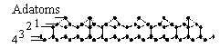 | 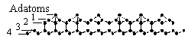
(a) | (b)

Fig.1. Starting (a) and spin-triplet equilibrated (b) atomic structure of the surface unit cell of the Si(111)7x7 surface [10]. From top to bottom, successively: top view of 1-2-3-4-layer, 3-4-layer, and 1-2-layer structures given in the Si-Si bond presentation, and side view of the structure as a whole.

(a) | (b)
 | (c)

Fig.2. a. Total distribution functions for the Si-Si bond lengths over 200 silicon atoms belonging to the DAS four-layer-and-adatom unit cell of the Si(111)7x7 surface [10]. 1. Spin-singlet configuration. 2. Spin-triplet configuration. 3. LEED model.
b. and c. Partial distribution functions for the Si-Si bond lengths for starting and spin-triplet configurations, respectively [10]. 1. Between layers 1 and 2. 2. Between layers 2 and 3. 3. Between adatoms and layer 1. 4. Between adatoms and layer 2. 5. Dimers.

(a)
(b)

Fig.3. Charge disribution over atoms belonging to the unit cell of the Si(111)7x7 surface. a. Spin-triplet configuration. b. Spin-singlet configuration [11].

Fig.4. Spin-density distribution over atoms belonging to the unit cell of the Si(111)7x7 surface. Spin-triplet configuration [11].

Fig.5. 1. and 2. Distribution of the free valency index over atoms belonging to the unit cell of the Si(111)7x7 surface for spin-singlet and spin-triplet configurations, respectively. 3. Absolute-value spin-density distribution [11].

Obviously, in this case the dangling-bond concept loses its meaning at all. On the other hand, the obtained data clearly show high chemical activity of the both SUCs atoms, much stronger for the spin-triplet SUC.
Figure 6 presents the electronic image of the spin-triplet SUC given as the LED contour map taken at 3Å above adatoms alongside with the experimental STM image. A similiraty of both images is quite convincing. Figure 7 shows the DOS spectrum of both spin-singlet and spin-triplet SUCs [9].
Fig.6. LED contour map taken 3Å above adatoms (spin-triplet configuration) consistent with an STM image of the Si(111)7x7 surface [25].
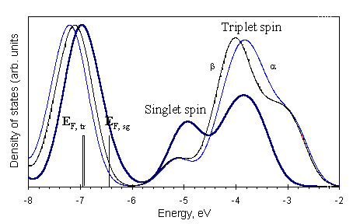

Fig.7. Density of electronic states for the surface unit cell of the Si(111)7x7 surface [26]. E_{F,sg} and E_{F,tr} mark the Fermi level energies of the spin-singlet and spin-triplet SUCs, respectively; α and β match spin-up and spin-down electron states.
The multiplicity plays only minor role in the spectrum distribution that evidences convincingly the metallic character of the surface for both SUCs Experimental observation of the metallic conductivity of the surface has been known for many years [26].
A brief account of a successive analysis of the QCh results presents a quite extended self-consistent view on the studied surface involving its peculiar characteristics concerning, in particular, the surface magnetism and electron deficiency behavior. The set of the data is a standard one for the QCh consideration of any surface. However, for brevity, in what follows we shall not follow the whole scheme but shall restrict ourselves to the consideration of particular points related to the surfaces of technological interest.

5. PARTICULAR TOPICS OF THE SURFACE STUDY
5.1. Bare surfaces.

The Si(111)7x7 surface discussed earlier is a good example of the bare surface study. When applying to the topic, the QCh tools answer well the question on the surface reconstruction first. Figure 8 exhibits another example when the reconstruction of the previously non-disturbed Si(001)1x1 surface into energetically more profitable Si(001)2x1 configuration occurs [12]. As in the case of the Si(111)7x7 surface, the spin-triplet configuration has the heat of formation 1.4 times lower than that of the spin-singlet one.

(a)
(b)

Fig.8. Equilibrated structure of the Si(001)2x1 surface [12]. Top (a) and side (b) views.

Electronic characteristics shown in Figure 9 evidence well-arranged atom charges within the layers and antiferromagnetic behavior of the surface. The free valency index behavior is similar to that of the Si(111)7x7 surface. The analysis of the two bare surfaces highlights that the their properties differ drastically from those of the species bulk. On the other hand, the reasons for the changes are quite fundamental. That is why similar changes, differed only quantitatively, should be expected practically for surfaces of all substances, and refractory compounds among them.
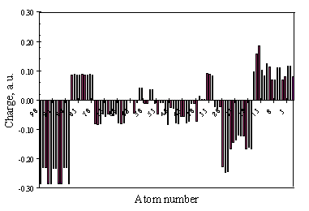
8th 7th 6th 5th 4th 3rd 2nd 1st
(a)
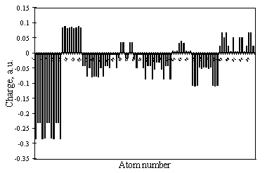
8th 7th 6th 5th 4th 3rd 2nd 1st
(b)

Fig.9. a. and b. Charge distribution for the spin-singlet and spin-triplet configurations of the Si(001)2x1 surface [12], respectively. Ordinal numbers correspond to the layer numbers.

5.2. Terminated surfaces.

As shown previously, bare surfaces are chemically active so that they become terminated readily when contacting the surrounding. In some cases, the surface termination or/and passivation is performed under special conditions. The process can be traced by the QCh calculations as well. Figure 10 presents the result of such consideration related to the hydroxylation of a silica protoparticle as a result of the interaction with water molecules.

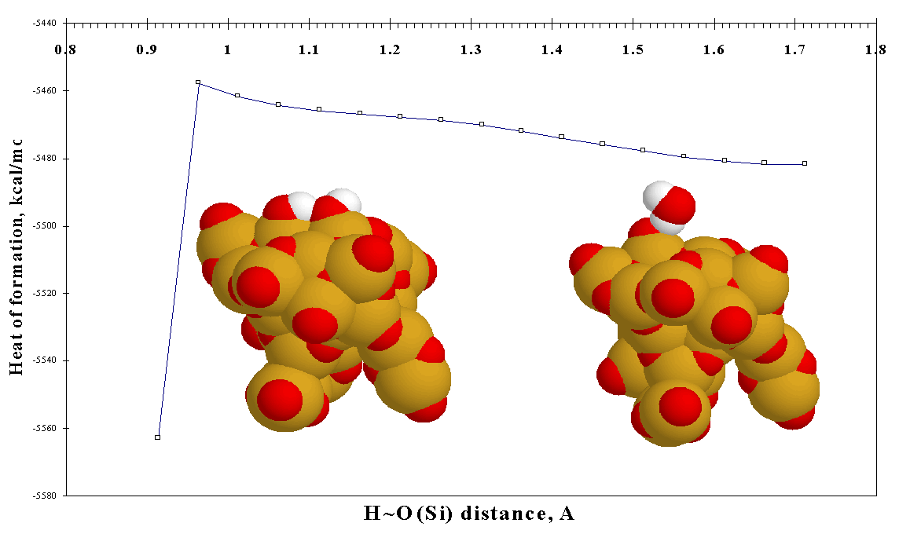
Fig.10. Reaction of the OH-termination of a silica protoparticle surface [27]. S. Starting equilibrated configuration of the complex with a water molecule attached to the particle via an H-bond (d_{H…O} = 1.70Å). F. Final configuration of the complex at d_{H-O} = 0.98Å with two silanol units on the surface.

The equilibrated configuration of the complex (the right picture in the figure) involves one water molecule, the latter is connected with the surface via an H-bond of 1.71Å in length [27]. At this stage the hydroxylation does not occur, which means it to be an energetically non-profitable so that there is a barrier for the reaction. To look for the latter, the calculation were performed [27] following the coordinate-of-reaction [28] technique while the O…H bond was considered as the reaction coordinate. The calculations were carried out under a constant-pitch contracting of the coordinate while all other coordinates were involved in the structure optimization procedure. As seen from the figure, the coordinate contraction causes an increase of the binding energy unless the coordinate length achieves 0.96Å that is characteristic for the standard O-H chemical bond length. A sharp drop of the binding energy occurs at the point showing that the attachment of two hydroxyl units to the surface is energetically profitable. The barrier energy thus determined constitutes about 20% of the total energy gain being at the same time not too large. Evaluations show that the barrier can be easily overcome under the conditions of the silica particle production which explains why the conventional fumed silica product consists of fully hydroxylated units [29].
Figure 11 presents some other examples of terminated surfaces whose equilibrated structures were studied quantum-chemically. It should be noted that the suggested termination modes were chosen when analyzing technological process of particle production. If in the case of fumed silica, the termination mode is quite obvious, in the case of silicon nitride and silicon carbide the point was rather obscure. The predictions made correlate well with the results of a thorough study of the surface vibrational spectra of the species [31].

(a)
(b)

(c)
(d)

(e)
(f)

Fig.11. Equilibrated structures of terminated surfaces; top views. a. Hydroxylated SiO₂ [13]; b. silylated SiO₂ [13]; c. hydroxylated Si₃N₄ [14]; d. aminated Si₃N₄ [14]; e. hydroxylated SiC [30]; f. hydrogenated SiC [30].

5.3. Interfaces.

Two examples of interfaces are presented below. The first is related to the adsorption layer of a five-member linear polydimethylsiloxane oligomer adsorbed on both hydroxylated and silylated surfaces of fumed silica [32-34] (see Figure 12) while the second highlights phenomena occurring at the interface of two colliding protoparticles of fumed silica [27,35] (Figure 13). The QCh tools used offer a good possibility to describe different aspects of the phenomenon studied. Thus, besides a quite good fitting obtained for the adsorption energy determined experimentally for technical fumed silica/silicone polymers mixtures, Figure 14 illustrates how informative is application of the partial distributive functions to describe spatial and electronic properties of the adsorbed molecule. As for the interface between two colliding particles, understanding the phenomena occurred at the place, namely, a non-barrier gluing of bare-surface particles (Figure 13a) and H-bonding of OH-terminated particles (Figure 13b), sheds light onto the origin of the grape-like aggregates of fumed silica fine particles (see Figure 15).
Side view
Side view

Top view Top view

(a) | (b)

Fig.12. Equilibrated interface structures. Adsorption of five-member linear polydimethylsiloxane oligomer (Si5) on hydroxylated (a) and silylated (b) silica protoparticle [32].

(a) | (b)

Fig.13. Equilibrated structure of interface between two bare-surface (a) and OH-terminated (b) silica protoparticles [27].

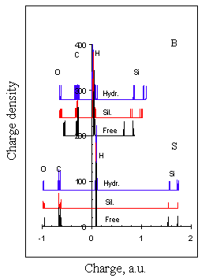 | 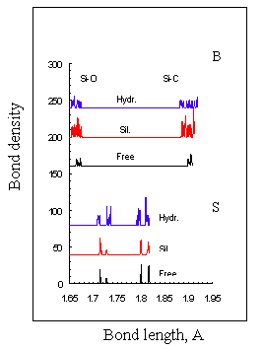
(a) | (b)

Fig.14. Distribution functions of charges (a) and bond lengths (b) for the Si5 oligomer both free and adsorbed on the hydroxylated (Hydr.) and silylated (Sil.) surfaces (see Figure 12) [32]. Two sets of the data are related to the straightened (S) and bent (B) siloxane chain configurations.

(a) | (b)

Fig.15. Electron micrograph [36] (a) and theoretical model [27] (b) for silica protoparticle aggregates.

6. SURFACES IN ELECTRIC FIELD AND UNDER MECHANICAL STRESS
6.1. Electric field impact.

The modern QCh approach makes allowance for the consideration of the surface at electric field. The approach suggested in [37] simulates the electric field of changeable configuration presented by a set of up to 200 point charges. Among various problems related to the field impact on the surface, there is a possibility to simulate phenomena occurring under the STM tip that happened to be quite successful [38-40]. Figure 16a shows the final result of the approach application to two-component system composed of a piece of α-C:H film immersed in liquid trichloroethylene and subjected to a pulsed electric field. The calculation exhibited a possibility of the field-stimulated oligomerization in the system which is threshold by nature and which occurred if only the tip is biased positively. Figure 16b presents experimental confirmation of the prediction [41]. Recently the STM-tip-field-stimulated desorption of hydrogen atoms from the Si(001)2x1H has been convincingly shown to take place at both polarities of the tip, however, with slightly higher threshold voltage applied to the positively biased tip [40]. The finding is fully consistent with experimental observations of the H-atom removal from the area under the STM tip [42].

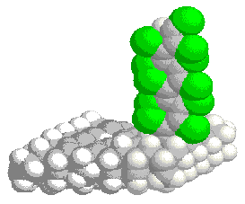
(a)
(b)

Fig.16. Field-stimulated graft oligomerization of trichloroethylene on the surface of
α- C:H film. a. Computational prediction [38]. b. Experimental observation [41].
6.2. Surface under mechanical stress.

A surface response to the mechanical stress application can be considered as a result of a mechanochemical reaction. Active development of the QCh tools described previously as well as steady building-up of computer facilities have made it possible to rise the question on transformation of modern computational chemistry into a computational mechanochemistry exploring the coordinate-of-reaction approach [28]. General concepts of such transformation have been considered in [43]. This is based on mechanochemical coordinate, both internal and external, specifying the deformational mode. The coordinates are subjected to constant-pitch changes and are excluded from the optimisation procedure. The remainder energy gradient along the coordinate determines the force of response equivalent to the stress in a conventional stress-strain characteristic. The approach was shown to be successful to both internal mechanochemical processes followed by chemical bonds rupture [44-46] and such external processes as mechanically stimulated dispergation, compaction, and friction [47]. Below two examples highlighting the above-mentioned processes are presented. Figure 17a shows the starting and final equilibrated configurations of a silica protoparticle subjected to uniaxial tension. An additional effect caused by the presence of a hydroxonium ion (a piloting agent of surfactants) is shown in Figure 17b. Clearly seen reduction of the force of response highlights Rebinder’s effect [48,49] disclosed quantum-chemically. The second example elucidates the friction between two molecules occurred as a result of shear deformation. A peculiar spike-like dependence of the force of response from the shear distance in Figure 18 is consistent with experimentally observed in many cases [50,51].

(a) | (b)

Fig.17. a. Rupture of a Si-O bond in a silica particle subjected to uniaxial tension.
b. The same but in the presence of a hydroxonium ion [45].

Contact area 7Å

Si5

Si15
(a)
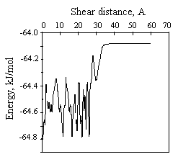  (b) | 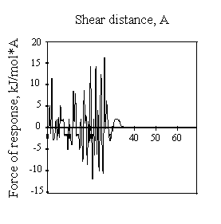  (c)

Fig.18. a. Two-molecule complex composed of Si5 and Si15 polydimethysiloxane oligomers subjected to shear deformation. b. and c. Heat of formation of the complex and the force of response, respectively [47].

7. CONCLUSION

The results presented in the paper do not pretend to exhibit an exhausted picture of the QCh approaches to the surface study. The review is limited to the data obtained by the author team only. One of the reasons of doing so was a wish to show how far and how deep is possible to go on the way of a self-consistent exploitation of the QCh approach oriented at the solution of technologically important material problems. Having chosen the approach, we have been aimed at its exhausted exploring to understand how well the considered nanoscale objects reflect a macroscopic reality of material science. On the other hand, we wished to get the real depth of the approach ability. Looking at the data obtained from this viewpoint, one can conclude that when the model cluster is really structurally complete the QCh approach reproduces the fundamental structural and electronic properties of the real surface quite well. Due to this, not enlarging the cluster size itself is seen as the approach weak point. In the majority of cases, the cluster sizes provided by the modern QCh tools are quite sufficient to disclose the fundamental properties of the surface. Sizing is important if only some coherency in properties is looked for. More important is inability to take into account temperature and time as real parameters of any technological process. Incorporation of the QCh results into modern MD techniques seems to be a promising way to the problem solution.

REFERENCES

- T.Cagin, J.Che, Y.Qi, Y.Zhou, E.Demiralp, G.Gao, W.A.Goddard III, Journ. Nanopart. Res., 1 (1998).
- P.A.M.Dirac, Proc.Roy.Soc.(London) 123 (1929) 714.
- I.N.Levine, Quantum Chemistry, 3rd Ed., Allyn and Bacon, 1986.
- A.Azabo, N.S.Ostlund, Modern Quantum Chemistry, McGraw-Hill, 1989.
- HyperChem. Computational Chemistry. Visualization and Simulation, Hypercube, Inc., Waterloo, Part2, 1994.
- M.J.S.Dewar, E.G.Zoebisch, E.F.Healy, J.J.P.Stewart, J.Amer.Chem.Soc., 107 (1985) 3902.
- J.J.P.Stewart, J.Compt.Chem., 10 (1989) 209, 221.
- E.F.Sheka, V.D.Khavryutchenko, E.A.Nikitina, Phys. Low-Dim. Struct., 1 (1995)
1-24.
- V.Khavryutchenko, E.Sheka, D.H.Huang, M.Aono, Phys. Low-Dim. Struct., 9/10 (1996) 15.
- V.Khavryutchenko, E.Sheka, M.Aono, D.H.Huang, Phys. Low-Dim. Struct., 11/12 (1996) 1.
- V.Khavryutchenko, E.Sheka, M.Aono, D.H.Huang, Phys. Low-Dim. Struct., 3/4 (1998) 81.
- E.Sheka, E.Nikitina, V.Khavryutchenko, M.Aono, 14th International Vacuum Congress, 31 August – 4 September 1998, Birmingham, UK, SS.PTh.91.
- V.Khavryutchenko, E.Nikitina, E.Sheka, H.Barthel, J.Weis, Low-Dim. Struct., 3/4 (1998) 1.
- E.Sheka, V.Khavryutchenko, E.Nikitina, I.Natkaniec, I.Markichev, N.Goncharova, V.Chukalin, J.Electr.Spectr.Rel.Phenom. 67 (1994) pp.133-139.
- V.A.Zayetz, CLUSTER-Z1 Quantum-Chemical Software, Institute of Surface Chemistry, Nat. Ac.Sci. of Ukraine, Kiev, 1990.
- V.A.Zayetz, CLUSTER-Z2 Quantum-Chemical Software, Institute of Surface Chemistry, Nat. Ac.Sci. of Ukraine, Kiev, 1990.
- V.A.Zayetz, spd-NDDO Approach for Calculations in the spd-Basis, Institute of Surface Chemistry, Nat. Ac.Sci. of Ukraine, Kiev, 1990.
- K.Ya. Burstein, A.N.Isaev, Theor. Chem. Acta, 64 (1984) 397.
- S.G.Semenov, in Razvitie uchenia o valentnosti (Evolution of the Valency Doctrine), Moscow, Khimia (1977) 17 (in Russian).
- K.B.Wiberg, Tetrahedron, 24 (1968) 1083.
- C.A.Coulson, Valence, Oxford Univ. Press, 2nd Ed. (1961).
- K.Takayanagi, Y.Tanishiro, M.Takahashi, S.Takahashi, J.Vac.Sci.Technol., A3 (1985) 1502; Surf. Sci., 164 (1985) 367.
- I.Ohdomari, private communication.
- J.Neamtu, private communication.
- H.Ushida, D.H.Huang, J.Yoshinobu, M.Aono, Surf. Sci., 287/288 (1993) 1056.
- U. Backes, H.Ibach, Solid State Communs., 40 (1981) 575.
- E.Sheka, V.Khavryutchenko, E.Nikitina, Journ. Nanopart. Res., is submitted.
- M.J.S.Dewar, Fortschr. Chem. Forsch., 23 (1971) 1.
- R.K.Iler, The Chemistry of Silica. Wiley, New York, 1979.
- A.Nikitin, E.Nikitina, private communication.
- M.-I.Baraton, these Proceedings, P.
- E.A.Nikitina, V.D.Khavryutchenko, E.F.Sheka, W.H.Barthel, J.Weis, Surf. Rev. Letts., 4 (1997) 879.
- E.A.Nikitina, V.D.Khavryutchenko, E.F.Sheka, W.H.Barthel, Word congress on particle Technology 3, Book of Abstracts, UK, Brighton, July 6-9 (1998) 193, p.103
- E.A.Nikitina, V.D.Khavryutchenko, E.F.Sheka, W.H.Barthel, J.Weis, Silica 98 from S (Synthesis) to A (Applications), Extended Abstracts, Mulhouse, France. 1-4 September, 1998, Vol.I, 467.
- E.Sheka, Word congress on particle Technology 3, Book of Abstracts, UK, Brighton, July 6-9 (1998), P.121.
- H.Barthel, M.Heinemann, M.Stintz, B.Wessely, Silica 98 from S (Synthesis) to A (Applications), Extended Abstracts, Mulhouse, France. 1-4 September, 1998, Vol.I, 323.
- E.F.Sheka, V.D.Khavryutchenko, V.A.Zayetz, Int. Journ. Quant. Chem, 57 (1996) 741.
- E.Sheka, V.Khavryutchenko, E.Nikitina, Phys. Low-Dim. Struct., 11/12 (1996) 65.
- E.Sheka, V.Khavryutchenko, E.Nikitina, Journ.Chem.Vap.Dep., 5 (1996) 1.
- E.Sheka, E.Nikitina, V.Khavryutchenko, M.Aono, 14th International Vacuum Congress, 31 August – 4 September 1998, Birmingham, UK, SS5.ThM.2.
- P.N.Luskinovich, V.D.Frolov, A.E.Shavykin, V.D.Khavryutchenko, E.F.Sheka, E.A.Nikitina, JETP Letts., 62 (1995) 881.
- K.Stokbro, C.Thirstrup, M.Sakurai, Ben Yu-Kuang, F.Perez-Murano, F.Grey, Phys. Rev. Letts., 80 (1998) 2618.
- V.Khavryutchenko, E.Nikitina, A.Malkin, Phys. Low-Dim. Struct., 6 (1995) 65.
- E.Nikitina, V.Khavryutchenko, I.Malkin, 9th International Conference on Surface and Colloid Science , Book of Abstracts, Bulgaria, Sofia, July 6-12 (1997) 792.G4, p. 421.
- E.Nikitina, V.Khavryutchenko, I.Malkin, International Symposium “Computer Assistance to Chemical Research”, Book of Abstracts, Moscow, December17-18 (1996) P66, p.79.
- E.Nikitina, V.Khavryutchenko, E.Sheka, H.Barthel, to be published.
- E.Sheka , International Fine Particle Research Institute, Annual Meeting’98, 29 June – 4 July 1998, Brighton, UK.
- P.A.Rebinder, Z.Physik 72 (1931) 191.
- P.A.Rebinder, E.D.Schukin, Progr.Surf.Sci., 3 (1972) 97.
- G.Vigil, Z.Xu, S.Steinberg, J.Israelashvili, Journ Coll. Interf. Sci., 165 (1994) 367.
- J.A.Harrison, S.S.Perry, MRS Bulletin, 23 (1998) 27.

Поступила в редакцию 20 марта 2001 года.

MNDO technique is the weakest among others within the NDDO approach. However, the MNDO/H method elaborated by Burstein and Isaev [18] should be mentioned if a quick search of H-bonding is necessary.

