ELASTO-PLASTIC ANALYSIS OF METAL FOAM CORE
SANDWICH STRUCTURES

A.J.M. Ferreira

Faculdade de Engenharia da Universidade do Porto, Porto, Portugal

ABSTRACT

The application of sandwich structures [1,2] has increased in the last decades, due to its high stiffness, low weight and good impact, sound and thermal properties. The recent use of sandwich structures with aluminum alloy foams and aluminum skins in the car industry has motivated this paper. The present work deals with the finite element analysis of such structures.
Higher-order shear deformation theories are applied in the finite element analysis of sandwich structures. The third-order and layerwise approaches are used. The elasto-plastic analysis is based on an associative flow formulation. A simply-supported beam is tested and analysed by finite elements. The agreement between finite element analysis and experimental results is very good.

1. INTRODUCTION

The mechanical behavior of metal foams was described by Banhart et al. [3,4]. Generally the compressive behavior of such foams can be described as in figure 1. The behavior is linear up to a long yielding plateau, after which some stiffening is possible. This behavior can be considered as elasto-perfectly plastic in most of the stress-strain curve. This sort of foams can be used as cores for sandwich constructions, as illustrated in figure 2. The behavior of sandwich structures made from aluminum skins and metal foams cores is the subject of this paper. In this work are applied higher-order shear deformation theories to the finite element analysis of such sandwich structures. The third-order and layerwise approaches are used [5-7]. The elasto-plastic analysis is based on an associative flow formulation [8-10]. The present formulation is compared with three-point bending results.

2. FINITE ELEMENT FORMULATION

Yang, Norris e Stavsky [11] have developed a theory of deformation based on the work of Mindlin [12] and Reissner [13] for isotropic plates. The displacement field is obtained as
(1)
where u, v and w are the x,y and z displacements. The u_{o}, v_{o} and w_{o} are the mid-plane displacements, and and the rotations of the normal.

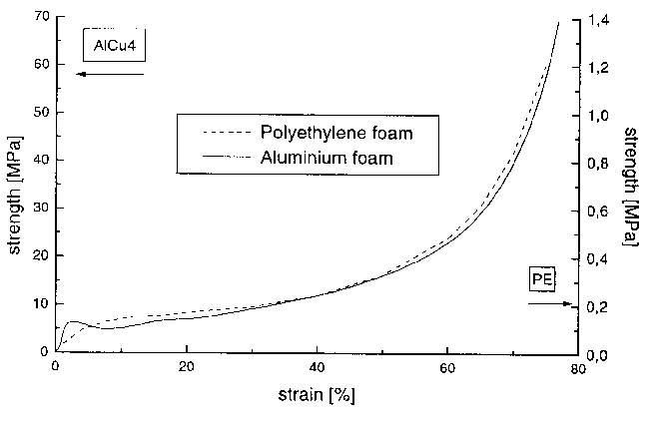
Figure 1: Behavior of metallic and plastic foams [4].

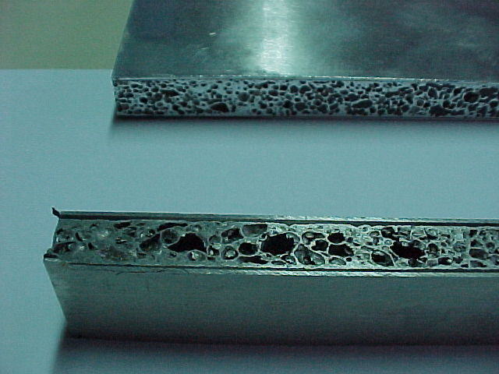

Figure 2: Aluminum skin/aluminum alloy foam core.

Strain-displacement relations can be expressed as
, (2)
where
(3)
are the membrane deformations and plane curvatures. In each layer k of the laminate the stress-strain relations are obtained as
(4)

where c_{ij} are elastic coefficients and {1,2,3} are the principal material directions for each layer. This theory is simple to implement, but introduces a shear correction coefficient [5-7] that affects only the shear terms. The higher order shear deformation theories avoid the use of the shear correction factors [5-7]. Various theories were proposed in the literature [14-16]. The model proposed in this paper has the following displacement field
(5)
where θ* represents the higher order rotations. In these theories the transverse displacement is constant througout the plate or shell thickness. This theory has the advantage that no shear-correction factors are needed. In sandwich laminates these theories present some difficulties. The layerwise theory proposed allows for a better deformation analysis in the laminate. In this work it is followed the concepts proposed by Manewya and Davies [17] for laminated plates. This concept was also explored by Al-Quarra [18] and Ferreira et al [5-7]. In this theory the displacement field for each layer (n) is a function of the displacements of other layers adjacent, as
(6)
The theories presented so far were implemented in the degenerated shell element [5-9,19,20]. The coordinates x of a point within the element are obtained as
(7)
The displacements for the first order shear deformation are obtained as
(8)
where as for the third order theory are obtained as
(9)
In the layerwise theory the displacements are obtained as
(10)
for the first layer and
(11)
where
(12)

for the other layers. The constitutive equations are derived for an orthotropic material with the material axes 1, 2 parallel to the plane x-y and rotated by some angle θ in relation to the axes x and y, being the material axe 3 parallel to z. Taking into account that $s_{z}=0$, the stresses at a layer of the element are related to the deformations by [19,20]
(13)
where
; ; ; (14)
is the strain transformation matrix, in which c = cos θ and s = sin θ, and $\overline{D}$ is the material elasticity matrix, defined for the material axes 1, 2, 3, having non-zero terms
; ; ; (15)
${\overline{D}}_{\text{12}}=ν_{\text{12}}{\overline{D}}_{\text{22}}$; ; ; (16)
in which $E_{1}$ and $E_{2}$ are the Young’s moduli in the 1 and 2 directions respectively, $ν_{\text{ij}}$ is Poisson’s ratio for transverse strain in the i-direction when stressed in the j-direction and $G_{\text{13}}$ and $G_{\text{23}}$ are the shear moduli in the 1-3 and 2-3 planes respectively; the terms and are shear correction factors in the 1-3 and 2-3 planes respectively [19,20]. In the third-order and in the layerwise theories, the shear correction factors are not considered in the formulation.

3. EXAMPLE

A simply-supported sandwich beam was tested in three-point bending. The dimensions of the beam, material characteristics and finite element mesh are illustrated in figure 3. The material considered have the following characteristics: Aluminium skins , Modulus=70 GPa, Yield stress=100 MPa; aluminium foam core, Modulus=6.5 GPa, Yield Stress =3 MPa. In figure 4 is illustrated the deformation of the beam. A compression failure occured in one of the beams. It is curious to observe the delamination at the skin-core interface. In figure 5 it is shown the load-displacement curve of the sandwich beam. The experimental results are compared with the finite element results. The agreement seems quite good.
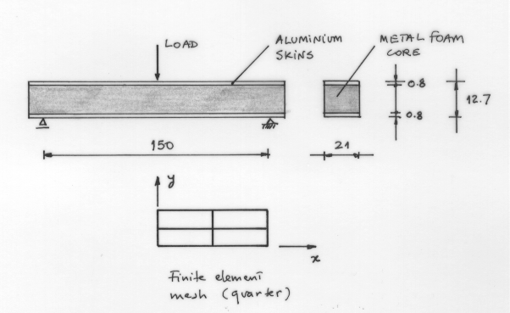
Figure 3: Sandwich beam in bending.

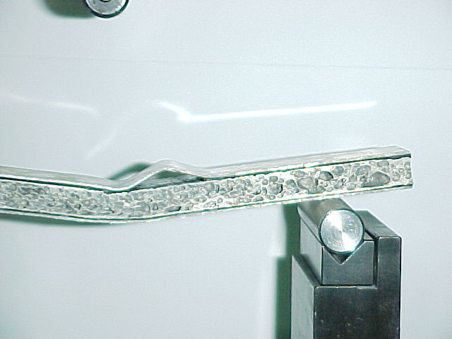
Figure 4: Three-point bending.

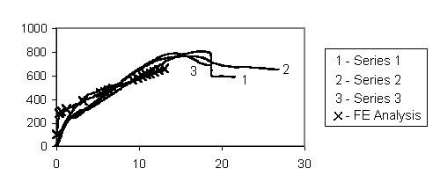
Figure 5: Load-displacement behavior.

4. CONCLUSIONS

The elasto-plastic formulation of sandwich structures was performed using several shear deformation theories. The first-order, third-order and the layerwise theories were applied. Three-point bending tests wrere performed on sandwich beams using aluminium skins and aluminium foam core. The experimental results agree well with the numerical results.

ACKNOWLEDGEMENTS

The supply of sandwich beams by Dr. John Banhart and the Fraunhofer Institute in Bremen, Germany, is gratefully acknowledged.

REFERENCES

- Allen H.G. Analysis and design of structural sandwich panels, Pergamon Press, UK, 1969.
- Zenkert D. The handbook of sandwich construction, EMAS, U.K., 1997.
- Banhart J. Production methods for metallic foams, Fraunhofer USA Metal Foam Symposium, 1997, pp.3-12.
- Yu C.-J., Banhart J. Mechanical properties of metallic foams, Fraunhofer USA Metal Foam Symposium, 1997, pp.37-48.
- Ferreira A.J.M., Barbosa J.T., Sá J.C., Marques A.T. Non-linear analysis of sandwich shells: the effect of core plasticity, accepted for publication at Computers and Structures.
- Ferreira A.J.M., Barbosa J.T., Sá J.C., Marques A.T. Geometric non-linear analysis of sandwich structures: 4th Int. Conference on Sandwich Construction, Stockholm, Sweden, 1998, pp.327-338.
- Ferreira A.J.M. Numerical models for the analysis of composite and sandwich laminated structures, Ph.D. Thesis (in Portuguese), Faculdade de Engenharia da Universidade do Porto, Porto, Portugal, 1997.
- Zienkiewicz O.C. The Finite Element Method, McGraw-Hill, N.Y., USA, 1977.
- Bathe K.-J. Finite Element Procedures in Engineering Analysis, Prentice-Hall, N.Y., USA, 1982.
- Hinton E. and Owen D.R.J. Finite Element Software for Plates and Shells, Pineridge Press, Swansea, UK, 1984.
- Yang P.C., Norris C.H., Stavsky Y. Elastic wave propagation in heterogeneous plates, Int. J. Sol. Struct., vol.2, 1966, pp.665-684.
- Mindlin R.D. Influence of rotatory inertia and shear in flexural motions of isotropic elastic plates, J. Appl. Mech., vol.18, pp.31-38, 1951.
- Reissner E. The effects of transverse shear deformation on the bending of elastic-plates, J. Appl. Mech., 12(2), Trans. ASME, vol.67, 1945, pp.69-77.
- Epstein M. and Glockner P.G. Nonlinear analysis of multylayered shells, Int. J. Solids Struct., 1977, vol.13, pp.1081-1089.
- Liao C.L. and Reddy J.N. A continuum-based stiffened composite shell element for geometrically non-linear analysis, AIAA J., 1989, vol.27, pp.95-101.
- Li Z.H. A refined finite element analysis of anisotropic laminated plates and shells, Ph.D.Thesis, University College of Swansea, 1988.
- Mawenya A.S., Davies J.D. Finite element analysis of multilayer plates, Int. J. Num. Meth. Eng., 1974, vol.8, pp.215-225.
- Al-Quarra H.H., Sallen H.G. Finite deflections of sandwich beams and plates by the finite element method, Dept. Civil Eng., Univ. Southampton, UK, 1980.
- Figueiras J.A. Ultimate load analysis of Anisotropic and Reinforced Concrete plates and shells, Ph.D. Thesis, c/ph/72/83, University College of Swansea, 1983.
- Ahmad S., Irons B.M. and Zienkiewicz O.C. Analysis of thick and thin shell structures by curved finite elements, Int. J. Num. Meth. Eng., 1970, vol.2, pp.419-451.

Поступила в редакцию 10 июня 2001 года.

