Fig.5. Finite element model of the DCB specimen, details of the crack-tip and J-integral path.

Note, that in the theory the model was investigated in the plane x-z, while the plain-strain FE model lies in the x-y plane. The through-the-thickness moduli was denoted by E_{y} is equal to E_{z}, the Poisson’s ratio denoted as ν_{xz} is equal to ν_{xy} in the FE model. The bridging fiber bundles were described by the pure properties of carbon-fiber: E₁₁=235 GPa, G₁₂=24 GPa and ν₁₂=0.28, according to [14]. The load/displacement data is shown in Table 1 with the corresponding crack lengths.

Table 1.
Load/displacement data for the carbon/epoxy and carbon/PEEK composites.

Carbon/epoxy |  |  | Carbon/PEEK
a [mm] | P [N] | δ [mm] | a [mm] | P [N] | δ [mm]
45 | 55.4 | 4.9 | 20 | 395 | 2.0
50 | 56.6 | 5.9 | 25 | 350 | 2.3
55 | 54 | 6.5 | 35 | 276 | 3.6
65 | 47.6 | 8.5 | 45 | 224 | 5.0
75 | 43 | 10.2 | 55 | 190 | 7.0
85 | 39.6 | 12.0 | 65 | 166 | 10.0
95 | 36 | 13.9 | 75 | 148 | 13.5
105 | 34.8 | 16.8 | 85 | 135 | 17.5
 |  |  | 95 | 125 | 21.5
 |  |  | 105 | 114 | 26.5
 |  |  | 115 | 112 | 33.0

7. RESULTS AND DISCUSSION
7.1. Results of the carbon/epoxy DCB tests.

Fig.6. shows the results of the finite element analysis and model predictions. The compliance and fracture toughness obtained from the models was compared with the experiments presented by Morais et al. [2]. Considering the compliance curves in Fig.6 it can be seen that the experimental values are slightly lower than the values from the FE and model predictions. The model including fiber-bridging gives closer values in comparison with the model without them, however there is not any significant difference in the two analytically obtained curves. The difference in the fracture toughness can be seen in the R-curves of the FE analysis. In Fig.6 the J-integral significantly overestimates the fracture toughness in the final stage of the delamination process if the assumed bridging fibers are missing. Since the J-integral gives reasonably good results until the crack length of a=65 mm it was assumed, that the fiber-bridging is the main cause of the former overpredictions. The corrected values are also depicted in Fig.6. In all the specimens it was estimated that the bridging bundles consist of 50-100 single fibers. The fiber-bridging form used was symmetrical arrangements and the number of fiber bundle pairs was increased until 4-5 pieces until the final crack length.
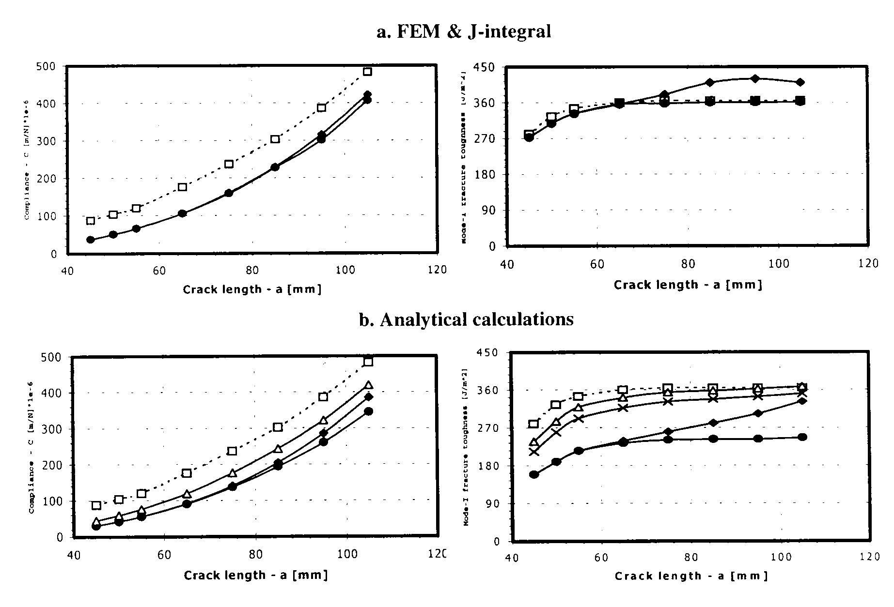
Fig.6. Compliance and R-curves for the carbon/epoxy DCB specimens. Experiments according to Morais et al. [ٱ], models without fiber-bridging [♦], models including fiber-bridging [•], models including fiber-bridging and elastic foundation compliance correction [x], models including fiber-bridging, compliance correction and fracture energy from the stress field behind the crack-tip [Δ].

Morais et al. reported initiation toughness of G_{ICinit}=280 J/m² and steady-state toughness of about G_{ICss}=365 J/m². The current FE model including fiber-bridging gives

