272.6 J/m² and 360 J/m² for the same quantities based on the J-integral. Considering the results of the simple beam theory without fiber-bridging no steady-state toughness can be determined. Since the beam theory is valid for composite specimens the experimentally measured and the curves of the beam theory should be parallel to each other, but in the final delamination stage the two curves almost coincide. The beam theory with bridging bundles partially eliminates this effect. The curves calculated considering the fiber-bridging and stress field behind the crack-tip give better correlation, but the best results were obtained in the case, including fiber-bridging, elastic foundation and the strain energy from the stress distribution behind the crack-tip. In the former case the elastic model gives G_{ICinit}=232.3 J/m² and G_{ICss}=362.1 J/m² for the initiation and steady-state toughness, respectively.

7.2. Results of the carbon/PEEK DCB tests.

Similar results were obtained in the case of carbon/PEEK composite specimens. Fig.7 illustrates the compliance and the mode-I fracture toughness calculated from the DCB tests.
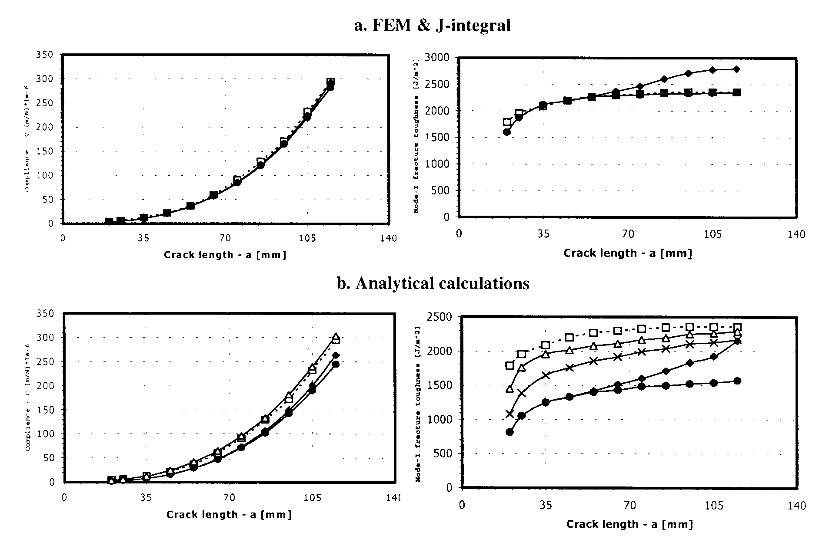
Fig.7. Compliance and R-curves for the carbon/PEEK DCB specimens. Experiments according to Hashemi et al. [ٱ], models without fiber-bridging [♦], models including fiber-bridging [•], models including fiber-bridging and elastic foundation compliance correction [x], models including fiber-bridging, compliance correction and fracture energy from the stress field behind the crack-tip [Δ].

Excellent results were presented for the compliance by both the finite element and analytical models. The fracture toughness values obtained by finite element calculations again are higher than the measured ones after the crack length of 55 mm. The application of symmetrically arranged bridging fiber bundles leads to reasonable fracture energy values. The FE model reports G_{ICinit}=1595 J/m² and G_{ICss}=2347.6 J/m² against the experimentally obtained G_{ICinit}=1790 J/m² and G_{ICss}=2360 J/m² values, presented by Hashemi et al. [6]. Considering the analytically obtained fracture energies the same conclusions can be taken as in the carbon/epoxy DCB specimens. No steady-state toughness exists until the bridging fiber bundles are missing. The correction due to elastic foundation and stress field behind the crack-tip is necessary to be considered for the best results. The corresponding initiation and steady-state toughness values: G_{ICinit}=1451 J/m² and G_{ICss}=2260 J/m², respectively. However both the FE and elastic models underpredicted the initiation fracture toughness, these results can be regarded as good correlation with the experiments. The former underprediction can be associated to the fact that the beam theory is strictly valid only for infinitely long crack lengths.

7.3. General discussion.

However both the FE model including fiber-bridging and the elastic model completed with other corrections due to elastic foundation and fiber-bridging gives more realistic results, the J-integral and the theoretical models are differently affected by the location and the length of the bridging fiber bundles. Using the J-integral the fracture toughness depends on the opening angle and the stress field around the crack-tip. Hence the J-integral is rather affected by the bridging fibers close to the crack-tip than the other ones, further from it. On the other hand using the beam theory in the applied equations the force, P and crack opening displacement, δ is considered at the location of loading point. Applying the current theory the opposite conclusions can be taken, i.e. the bridging fibers, which are closer to the loading point, cause lower COD, correcting the overpredictions. The former mechanisms, which affect the computations, are depicted in Fig.8.
Fig.8. Deformed shape and crack-tip details with and without fiber-bridging.

The fracture energy, calculated from the stress field behind the crack-tip was found to be increasing with the crack length. This was also proved by finite element calculations, however in the stress values at the crack-tip significant differences were experienced. The FE model gives 400-500 MPa maximal value for the stress component σ_{z}, while the analytical model shows only 8-10 MPa for the same quantity. This overprediction using the FE model can be the consequence of the fact, that the crack-tip is singular point in the stress field, and stress concentration can occur by refining the FE mesh. In the theory there is no stress singularity.

8. CONCLUSIONS

Unidirectional carbon/epoxy ([0°]₂₄) and carbon/PEEK ([0°]₄₀) DCB specimens were investigated analytically and numerically. The fiber-bridging phenomenon was analysed based on linear elastic beam theory and generalized closed-form equations were derived for the compliance and for the fracture toughness. Previous computations showed that the simple beam theory gives very poor results for high axial modulus composite DCB specimens in comparison with the experimentally measured fracture toughness. The stress field behind the crack-tip was found to be another source of fracture energy, which should be accounted to obtain reasonably good fracture energy values. Elastic foundation correction factors due to crack-tip rotation were also used. The best results were obtained by the models, which accounts for fiber-bridging, elastic foundation and the stress field behind the crack-tip. The fracture toughness was evaluated fully analytically and very good predictions were made. Numerical computations were also carried out based on the J-integral. The finite element analyses also showed large overpredictions in comparison with the experimental fracture tests. After the fiber-bridging phenomenon was considered result showed excellent correspondence with the experiments for both the compliance and the mode-I interlaminar fracture toughness. The following conclusions were taken:
• the beam theory shows, the fiber-bridging cause a term in the specimen compliance, which has the quadratic and cubic power of the crack length;
• if the fiber-bridging is not considered, the beam theory, as well as the J-integral overpredicts the fracture energy based on the experimental load-displacement curves;
• the stress field behind the crack tip should be accounted ass another source of fracture energy;
• the beam theory formulas are affected by fiber-bridgings, closer to the loading point significantly, while the J-integral is rather affected by the fiber bundles closer to the crack tip.

The fiber-bridging phenomenon is also observable in laminated angle-ply composites. There are other practical problems in composite DCB specimens considering the fiber-bridging. For instance the nonuniform distribution of the fracture energy along the specimen width, curved crack front, the effects of stacking sequence on the fiber-bridgings, etc. These problems have planned to be solved by us in the future.

9. REFERENCES

- Ozdil F., Carlsson L.A. Beam analysis of angle-ply laminate DCB specimens. Composites Science and Technology, 1999, v.59, pp.305-315.
- Morais A.B., Moura M.F., de, Marques A.T., Castro P.T. Mode-I interlaminar fracture of carbon/epoxy cross-ply laminates. Composites Science and Technology, 2002, v.62, pp.679-686.
- Suppakul P., Bandyopadhyay S. The effect of weave pattern on the mode-I interlamianr fracture energy of E-glass/vinyl ester composites. Composites Science and technology, 2002, 62, pp.709-717.
- Shen F., Lee K.H., Tay T.E. Modelling delamination growth in laminated composites. Composites Science and Technology, 2001, v.61, pp.1239-1251.
- Dubois F., Keunings R. DCB testing of thermoplastic composites: a non-linear micro-macro numerical analysis. Composites Science and Technology, 1997, v.57, pp.437-450.
- Hashemi S., Kinloch J., Williams J.G. The effects of geometry, rate and temperature on mode I, mode II and mixed-mode I/II imterlaminar fracture toughness of carbon-fibre/poly(ether-ether ketone) composites. Journal of Composite Materials, 1990, v.24, pp.918-956.
- Hashemi S., Kinloch J., Williams J.G. Mechanics and mechanisms of delamination in a poly(ether sulphone)-fibre compsoites. Composites Science and Technology, 1989, N378, pp.429-462.
- Dahlen C., Springer G.S. Delamination in composites under cyclic loads. Journal of Composite Materials, 1994, v.28, pp.732-781.
- Broek D. Elementary engineering fracture mechanics. Martinus Nijhoff Publishers, The Hauge, 1982.
- Tanzawa Y., Watanabe N., Ishikawa T. FEM simulation of a modified DCB test for 3-D orthogonal interlocked fabric composites. Composites Science and Technology 2001, v.61, pp.1097-1107.
- Tanzawa Y., Watanabe N., Ishikawa T. Interlaminar fracture toughness of 3-D orthogonal interlocked composites. Composites Science and Technology 1999;59;1261-1270.
- Heck A. Introduction to Maple. Springer-Verlag 1993.
- Kenane M., Benzeggagh M. L. Mixed-mode delamination fracture toughness of unidirectional glass/epoxy composites under fatigue loading. Composites Science and Technology, 1997, v.57, pp.597-605.
- Fiedler B., Hojo M., Ochiai S., Schulte K., Ochi M. Finite-element modeling of initial matrix failure in CFRP under static transverse tensile load. Composites Science and Technology, 2001, v.61, pp.95-105.

Поступила в редакцию 30 сентября 2002 года.

