Impact fragmentation dependence on geometrical parameters of single MESH bumpers

Semenov A.⁽¹⁾, Bezrukov L.⁽¹⁾, Malkin A.⁽²⁾, Myagkov N.⁽³⁾, Kononenko M.⁽³⁾, Shumikhin T.⁽³⁾

(1) Federal Research Institute of Aviation Systems
(2) Institute of Physical Chemistry of RAS
(3) Institute of Applied Mechanics of RAS

ABSTRaCT

The work presents results of eight tests in which an aluminum spherical projectile (diameter D₀=6.35mm) impacted bumper consisted of single steel grid. Impact velocities were in range of 3 250 – 3 400 m/s. The main objective of experiments was to reveal the dependence of behind-bumper fragment distribution of mass on the geometrical characteristic parameter ε = D₀ /(d_{w}+l) (d_{w} is wire diameter and l is mesh size) as well as to find out whether the central leader element in the against-mesh bumper impact debris cloud is an intact object or a compact sub-cloud of weighty fragments. Also, as a matter of interest was to clarify the characterization of the central leader element as a function of geometrical parameter ε. The projection of debris cloud fragments imprinted as a set of various size craters on a witness plate located at the distance of 150 mm behind the bumper. The witness plate was chosen thick enough to estimate the mass distribution of the fragment on the base of relation between crater volume and kinetic energy of object penetrating half-infinite solid. To make the crater imprinting more distinguishable (especially for the weightiest fragments that have less lateral dispersion) all tests were performed in the air under normal atmospheric condition.

1. INTRODUCTION

Since the launch of Sputnik on 4 October 1957 and up to these days, more than 4300 rocket launches have placed 6000 satellites into orbit. And each launch adds garbage to the space environment. This garbage, i.e. non-functional man-made objects, is called space debris. Step by step having size from a few tenths of a millimeter up to dozens of centimeters and orbital velocity up to 15 km/s the space debris becomes a significant problem for the faultless functioning of satellites and especially for the safe exploration of manned spacecraft during long-duration flight.
The space debris objects with size down to 1 cm can be detected by special telescope and sensor radar space- and ground-based facilities. Up today about 9 000 objects are cataloged. The observation and determination of orbital characterization of these objects allows spacecrafts avoiding fatal orbital collision. The protection against sub- and centimetric size objects (up to 1.5 centimeter) is based on the technology of spacecraft shielding against meteoroids and space debris which allows mitigation of risk assessment during hypervelocity impact.
The basic principle of hypervelocity impact shielding protection is not complicated. Modern protection constructions of the orbital modules are based on particles impact fragmentation on the shields. Well-known scheme of Whipple shield (Whipple, 1947) provides fragmentation of projectile after the impact on solid bumper (plate) so the probability of rear wall perforation (or total damage) becomes lower (Fig.1) because of the projectile fragment momentum dispersion on wider area of protected rear wall. So the protection quality is determined by the effectiveness of the particles fragmentation (characteristic size of the destruction fragments) and value of the cone of fragments recession angle (transversal momentum of fragments due to impact destruction of the particle).

Fig.1. Traditional Whipple scheme.

The spacecraft shield protection is an engineering structure and should satisfy some requirements such as high reliability, constructional simplicity and lightweight. So for at least 15 last years the matter of interest was permanent work aimed on the improvement of the shield protection effectiveness.
In the “light”-weight protection structure the first bumper must provide a maximum effective fragmentation of the projectile (and optimal in sizes of the fragments) and a maximum angle of scattering. It can be done if the first bumper is optimal from this point of view because the projectile has the maximum kinetic energy at the first bumper.
The shield protection properties of continues bumper are described and studied enough well [1,2]. A lot of works were executed on testing of shield protection structure composed of different materials.
The efficiency of mesh (discontinues) bumper has been shown first time in the work dedicated to comparable series of experiments with composite and heterogeneous bumpers [3]. Later more detailed research revealed favorable and unfavorable features properties of mesh bumpers [4]. In spite of these investigation and some other ones the physical processes that accompanying fragmentation are still quit unclear, as well as the influence on the fragmentation of grid materials and mesh geometrical parameters. It is qualitatively clear that in case of mesh bumper the process of fragmentation goes in different way then in case of continuous one because unloading and destruction of a projectile starts practically instantly from its frontal surface, after its interaction with a mesh. Nevertheless the typical distribution of damage craters and holes on the rear wall after projectile collision with continues and discontinues bumpers are quit similar for both cases. It is as usual the hole or crater in the center of damaged surface produced by the most kinetic so-called central leader surrounded by the lighter damages with relatively wide lateral dispersion (Fig.2).
Obviously the central leader presents most dangerous risk then other fragment elements of which consist the behind bumper debris cloud (the fragment elements of the behind bumper debris cloud were described and classified by Piekutowski [1], also model of impact debris cloud in [6]).
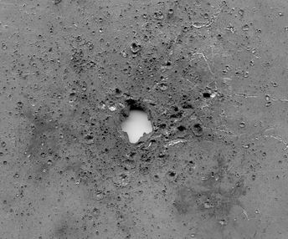

Fig.2. Typical damages on the surface of the rear wall after projectile collision with a single thin bumper.

Taking into consideration the above mentioned gap in knowledge on the influence of geometrical property of mesh on after-collision projectile fragmentation and especially on dynamical state of the central leader some research objectives may be formulated as follow:
- How the impact fragmentation depends on the geometrical mesh parameters?
- Could be improved the mass distribution of fragments (at least decreased the mass of the central leading fragment) by varying of only mesh parameters?
- Is the central leader element an intact particle or just a compact cloud of weighty fragments?

2. EXPERIMENT DESCRIPTION

The thick plates of aluminum alloy placed on path of behind-bumper debris cloud have been used as witnesses to get data for after-impact fragment mass distribution. The use of the relatively thick rear wall as a witness can be very informative because it can help estimate the volumes of craters considering them as a result of catering in a half-infinite solid. The crater volume was estimated as a volume of hemi-ellipsoid (Fig. 3). In total the quantity of processed craters for each experiment was about 1000-1500. The size of smallest was about 0.1 mm.

Fig.3. A scheme of crater volume estimation. 1) Estimation of the crater area by an ellipse. 2) Location scheme of damaged witness plate estimation ellipses 3) Estimation of crater volume by hemi-ellipsoid. R – major ellipse hemi-axis,
r – minor ellipse hemi-axis

The kinetic energy K_{i} of individual behind-bumper fragment that left crater on the thick witness plate can be estimated considering well known relation K_{i} ~ V_{c} where V_{c} is the volume of the crater [7]. The assumption that the velocity v_{i} of different behind-bumper fragments are roughly equal provides the distribution of the fragment masses m_{i}. For special definition of leader fragment relative mass the parameter μ is introduced μ=M_{L} /M_{t,} where M_{L} is an estimated volume of leader fragment crater and M_{t} is a total volume of all estimated craters on the witness plate. To characterize the geometrical parameter of the mesh it is convenient to introduce the parameter
ε = D₀ /(d_{w}+l),
where d_{w} - wire diameter l - mesh size, and D₀ – spherical projectile diameter (Fig.4)

Fig.4. a) Arranged notation on mesh parameters; b) Photo of a aluminum projectile D₀=6.35mm and a steel mesh 0.6×2.0 mm; c) Photo of a aluminum projectile D₀=6.35mm and a steel mesh 1.0×2.0 mm

It is important to note that the experiments were carried out in the air under normal atmospheric pressure condition. That provides the additional lateral dispersion of the behind-bumper debris particles and that was important for the more distinct imprinting of craters on the witness plate. Especially it is important to distinguish the debris particles of which the central leader element consists, of course in case that this element is not a kind of intact object.

3. EXPERIMENT RESULTS

A special series of experiments were dedicated to the investigation of the state of the fragments which constitute the central element of the debris cloud and pose the most threat of the rear wall perforation. The problem is to find out if the hole in the wall is a result of impact of a single fragment or it is a result of multi impact of several fragments moving closely together. If the last assumption is right than the air dynamic force can segregate these fragments.
The experiments were carried out on a light-gas two stage cannon.

Fig.5. Scheme of the experiments DZR01-DZ R08.
For clarification 8 experiments were conducted under the normal atmosphere pressure (DZR01, DZR02, DZR03, DZR04, DZR05, DZR06, DZR07, and DZR08). Dispersion of the fragments was fixed on the witness plate (WP). The WP was the plate of aluminum alloy (AMG6, in Russian marking) with thickness more than 15 mm (except DZR04 where the thickness of the rear wall was 3 mm). Fig.5 suggests the scheme of the experiments.

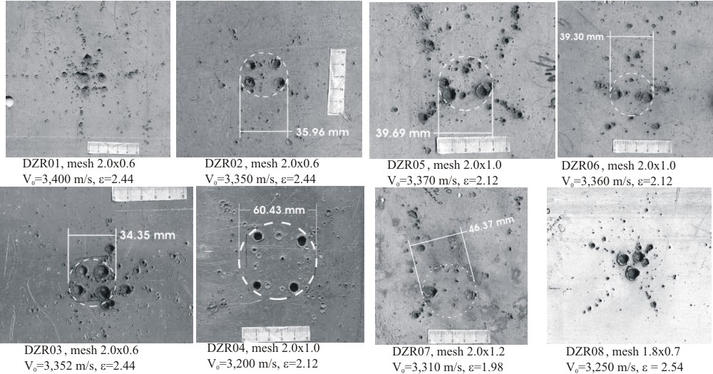

Fig.6. Photos of the whiteness plate surface damage (experiments: DZR01-DZR08).

The presented photographs (Fig.6) show that the leading most dangerous fragment acted on the rear wall as an intact object really may consist of several smaller fragments. Due to the action of the air the coarse fragments of a projectile become distinguishable. The parameter μ for these experiments was estimated for the 4 heaviest fragments.
Below are presented the detailed description of typical experiments DZR05 and DZR06. The main difference between them consists in number of heaviest fragments: 4 heavy fragments in DZR05 and only 2 heavy fragments in DZR06.
For characterization of the behind-bumper scattering cone was used the following parameters:
D - an average diameter of scatter region where craters greater than 1-mm size are available,
φ – an angle of the scattering of these fragments (evidently φ = 2 arctg( (D / 2 ) / S ) , S – base distance between a bumper and a witness plate.
D_{L} – an average diameter of most heavy fragment scatter region
φ_{L} – an angle of the heaviest fragments scattering.

Experiment DZR05
The damage of the WP:
- The central zone of WP has four craters with diameter 7mm - 9 mm. The average diameter of this zone is D_{L}=39.69 mm, the angle is φ_{L}=16.7 degree.
- The average diameter of scattering of small craters is D=210.89 mm (for craters with the size ≥ 1 mm); φ=70.2 degree.
- The quantity of the craters with size more than 1 mm is about 210.
- μ₁ = 0.20; μ₂ = 0.13; μ₃ = 0.10; μ₄ = 0.08

Experiment DZR06
The damage of the WP:
- The central zone of WP has two craters with diameter 6 mm - 10 mm. Their scattering diameter is D_{L}=39.30mm, the angle is φ_{L}=16.6 degree.
- The average diameter of scattering of small craters (~1mm) is D=208.27mm, the angle is φ=69.54degree.
- The quantity of the craters with size more than more than 1 mm is about 120.
- μ₁ = 0.25; μ₂ = 0.23; μ₃ = 0.06; μ₄ = 0.05

The parameter μ was estimated for all these experiments. In Fig.7 is depicted the dependence of μ on the geometrical and weight parameters of mesh used in these experiments. It seems that the areal density of the meshes don’t influence on μ.
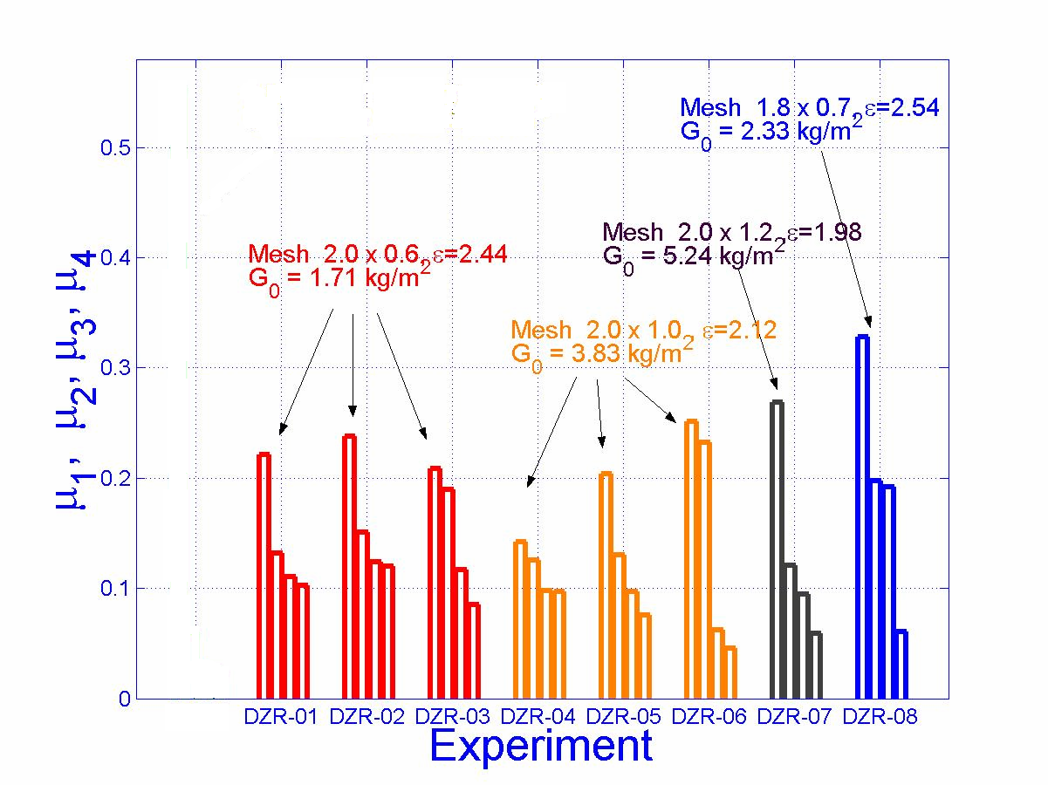
Fig.7. Dependence of μ on the mesh parameters.

In the fig.8 presented two characteristic type of fragmentation observed in the experiments (four leading fragments and two leading fragments) and the dependence of the type on the geometrical parameter ε.
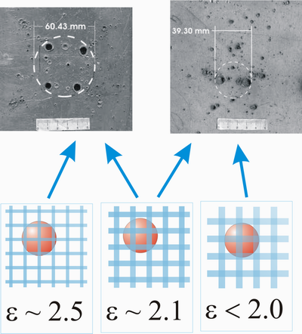
Fig.8. The dependence of fragmentation type on the parameter of ε.
4. CONCLUSION

The analysis of the experiments shows that the mesh bumpers can provide the steady fragmentation of the projectile in which the parameter μ of the biggest fragment not exceed the value of μ = 0.25 in the range of meshes with ε ∼ 2.1–2.5 (at least for the interval of impact velocity 3,250 – 3,400 m/s). Also it seems that the geometrical parameter of meshes of such value of ε have more influence on mass distribution of leading fragments than mesh weight characteristic. Apparently in case of mesh bumper so called implantation mechanism of fragmentation prevails in contrast of scabbing mechanisms in case of continuous bumper. The implantation of wire into the body of projectile causes the appearance of disjoint forces leading to complete separation of coarse fragments. The geometrical parameter of the mesh seems to be a control parameter of the process as well as impact velocity. Also the influence on fragmentation of ratio d_{w}/l needs some additional studies. In the experiments the ratio of the used mesh bumper was in the range d_{w}/l=0.3–0.6. The mesh with geometrical (and may be material) parameters that provide the fragmentation that give the smallest parameter μ may be denominated as “optimized mesh” (for some effective size of projectile).
In case of the impact projectile fragmentation after the collision against “optimized” mesh bumper performed in vacuum the scattering of the heaviest debris fragments would not take place so expectable value for μ , determined by the volume of the central crater would be about μ = 0.5 or more. That value corresponds to estimations made for similar experiments that were carried out in the evacuated chamber.

REFERENCES

- Piekutowski, A. J., Int. J. Impact Engng., 1995, v.17, pp.627-638.
- Grady, D.E. and Kipp, M.E. Int. J. Impact Engng., 1997, v.20, pp.293-308; Grady, D.E. and Winfree, N.A., Int. J. Impact Engng., 2001, v.26, pp.249-262.
- Christiansen, E.L., AIAA Paper No. 90-1336, 1990.
- Horz, F., Cintala, M.J. et al., NASA TM 104749, 1992; Horz, F., Cintala, M.J. et al., Int. J. Impact Engng, 1995, v.17, pp.431-442.
- Cohen, L.J., Int. J. Impact Engng., 1995, v.17, pp.229-240.
- Balankin, A., Lubomudrov, A., Sevrukov, I., Physics of the hyper-velocity impact, Ministerstvo oborony SSSR, Moscow, 1990 (in Russian).

Поступила в редакцию 24 марта 2006 года.

This work was supported from International Science and Technology Center (project #1917).

